**A**

Project Report

On

**Mp3 Music Player**

*Submitted in partial fulfilment of the*

*Requirement for the award of the degree*

*Of*

**MASTER OF COMPUTER APPLICATION**

*Submitted by*

**[ANSHU SHARMA]**

**[201810101040701]**

**[Dr. Bineet Kumar Gupta, Mr. Kamal Soni ]**

**Session – 2019-20**

*Under the Guidance of*

**Mr. Yogesh Pal Singh**



**DEPARTMENT OF COMPUTER APPLICATIONS**

**SHRI RAMSWAROOP MEMORIAL UNIVERSITY, LUCKNOW-DEWA ROAD**

**BARABANKI**

**NOV-2019**

**CERTIFICATE**

This is to certify that Mr. Anshu Sharma has partially completed the Training in our Organization UPTEC Computer Consultancy Ltd during the period 01-05-12 to 15-06-12. His overall performance during the period was excellent.

Signature & Seal of Training Manager

**DECLARATION**

I hereby declare that this submission is my own work and that, to the best of my knowledge and belief, it contains no material previously published or written by another person nor material which to a substantial extent has been accepted for the award of any other degree of the university or other institute of higher learning, except where due acknowledgment has been made in the text.

**Name ANSHU SHARMA**

**Signature**

**Roll No. 201810101040701**

**Date**

**ACKNOWLEDGEMENT**

It gives us a great sense of pleasure to present the project report of the MCA Project undertaken during MCA. Final Year VI Semester. We owe special debt of gratitude to Mr. Yogesh Pal Singh , Department of Computer Application, Shri Ramswaroop Memorial University for his constant support and guidance throughout the course of our work.

We also take the opportunity to acknowledge the contribution of Dr. Bineet Kumar Gupta Head, Department of Computer Application, Shri Ramswaroop Memorial University, Lucknow for his full support and assistance during the development of the project.

We also do not like to miss the opportunity to acknowledge the contribution of all faculty members of the department for their kind assistance and cooperation during the development of our project. Last but not the least, we acknowledge our friends for their contribution in the completion of the project.

**Name : ANSHU SHARMA**

**Signature:**

**Roll No.: 201810101040701**

**Date :**

**PREFACE**

Development of large Web Site is an extremely complex activity with full of various opportunities to introduce errors. Software engineering is the discipline that attempts to provide methods to handle this complexity, enabling us to produce reliable software system with maximum productivity.

It was felt that it is important, and very instructive, not only to learn the principles of software engineering but also apply them to a Web Sitedevelopment project so that all aspects of development can be clearly seen on a project.

Software Engineering activity start from requirement analysis and ends with testing and implementation. The sequence of performed during Web Sitedevelopment.The system has passed through all type of testing phases but due to lack of time, I am not able to text it from the clients point of view and could not implement it.

I am thankful to our teachers and guide for their sincere efforts towards the completionof this document.

This report is divided in two parts. The first part gives the basic information about the project, the tools used & system analysis. The second part consists of system design showing various input & output screens that give a brief overview of the entire system. At the end, we have provided a short list of reference books that provide useful during the development.

**TABLE OF CONTENT**

|  |  |  |
| --- | --- | --- |
| S.No. | TOPIC | Page No. |
| **I.** | **ACKNOWLEDGEMENT** | **2** |
| **II.** | **CERTIFICATE** | **3** |
| **III.** | **DECLARATION** | **4** |
| **IV.** | **PREFACE** | **5** |
|  |  |  |
| **1.** | **INTRODUCTION** | **7-8** |
|  |  |  |
| **2.** | **ANALYSIS** | **`9-12** |
| **2.1** | System Analysis | **10-11** |
| **2.2** | System Specification | **12** |
| **3** | **DESIGN** | 13-27 |
| **3.1** | UML | **15-21** |
| **3.2** | DFD | **22-25** |
| **3.3** | ER Model | **26-27** |
| **4.** | **MODULE** | **28-29** |
|  |  |  |
| **6.** | **DATABASE TABLE** | **30-32** |
| **7.** | **TESTING** | **33-42** |
| **8.** | **CODING** | **43-97** |
| **9.** | **OUTPUT SCREEN** | **98-112** |
| **10.** | **CONCLUSION** | **113** |
| **11.** | **FUTURE SCOPE & ENHANCEMENT** | **114** |
| **12.** | **REFERENCES** | **115** |
|  |  |  |
|  |  |  |

****

**INTRODUCTION:**

Online Examinations System contents providers to focus on creating effective assessment questions and focusing on exam’s feedback delivery to students. In the paper we present techniques that are pertinent to the elements of assessment process: answers submission, computerized grading, and feedback after submission.

As the modern organizations are automated and computers are working as per the instructions, it becomes essential for the coordination of human beings, commodity and computers in a modern organization.

The administrators, instructor, Students who are attending for online examination can communicate with the system through this projects, thus facilitating effective implementation and monitoring of various activities of Online Examinations like conducting Exams as per scheduled basis and delivering result to that particular use or student. And the details of students who attempted Online Examination are maintained at administrator.

**SYSTEM ANALYSIS**:

1. Existing System

Existing system is a manual one in which users are maintaining books to store the information like Student Details, Instructor Details, Schedule Details and feedbacks about students who attempted exam as per schedule.. It is very difficult to maintain historical data.

DISADVANTAGES:

The following drawbacks of existing system emphasize the need for computerization:

1. A lot of copies of question papers have to be made

2. A lot of correction work hence delay in giving the results

3. A lot of tabulation work for each subject results

2. Proposed System

This application is used to conduct online examination. The students can sit at individual terminals and login to write the exam in the given duration. . The questions have to be given to the students.This application will perform correction, display the result immediately and also store it in database. This application provides the administrator with a facility to add new exams.This application provides the Instructor add questions to the exam, modify questions in the exam in a particular exam. This application takes care of authentication of the administrator,Instructor as well as the student.

3. Objective of the System

The objective of the Online Examination Tool is to provide better information for the users of this system for better results for their maintainence in student examination schedule details and grading details**.**

# 

**System Specifications**

Hardware Requirements:-

* Pentium-IV(Processor).
* 256 MB Ram
* 512 KB Cache Memory
* Hard disk 10 GB
* Microsoft Compatible 101 or more Key Board

Software Requirements: -

* **Operating System :** Windows
* **Web-Technology: PHP**
* **Front-End: HTML,CSS,JAVASCRIPT**
* **Back-End:** MySQL
* **Web Server:** Apache SERVER.



INTRODUCTION:

Design is the first step in the development phase for any techniques and principles for the purpose of defining a device, a process or system in sufficient detail to permit its physical realization.

Once the software requirements have been analyzed and specified the software design involves three technical activities - design, coding, implementation and testing that are required to build and verify the software.

The design activities are of main importance in this phase, because in this activity, decisions ultimately affecting the success of the software implementation and its ease of maintenance are made. These decisions have the final bearing upon reliability and maintainability of the system. Design is the only way to accurately translate the customer’s requirements into finished software or a system.

Design is the place where quality is fostered in development. Software design is a process through which requirements are translated into a representation of software. Software design is conducted in two steps. Preliminary design is concerned with the transformation of requirements into data.

UML Diagrams:

Actor:  
 A coherent set of roles that users of use cases play when interacting with the use `cases.

Use case:

A description of sequence of actions, including variants, that a system performs that yields an observable result of value of an actor.

UML stands for Unified Modeling Language. UML is a language for specifying, visualizing and documenting the system. This is the step while developing any product after analysis. The goal from this is to produce a model of the entities involved in the project which later need to be built. The representation of the entities that are to be used in the product being developed need to be designed.

There are various kinds of methods in software design:

They are as follows:

* Use case Diagram
* Sequence Diagram
* Collaboration Diagram
* Activity Diagram
* State chat Diagram

**USECASE DIAGRAMS:**

Use case diagrams model behavior within a system and helps the developers understand of what the user require. The stick man represents what’s called an actor.

Use case diagram can be useful for getting an overall view of the system and clarifying who can do and more importantly what they can’t do.

Use case diagram consists of use cases and actors and shows the interaction between the use case and actors.

* The purpose is to show the interactions between the use case and actor.
* To represent the system requirements from user’s perspective.
* An actor could be the end-user of the system or an external system.

**USECASE DIAGRAM:**

A Use case is a description of set of sequence of actions. Graphically it is rendered as an ellipse with solid line including only its name. Use case diagram is a behavioral diagram that shows a set of use cases and actors and their relationship. It is an association between the use cases and actors. An actor represents a real-world object. Primary Actor – Sender, Secondary ActorReceiver.



**SEQUENCE DIAGRAM:**

Sequence diagram and collaboration diagram are called INTERACTION DIAGRAMS. An interaction diagram shows an interaction, consisting of set of objects and their relationship including the messages that may be dispatched among them.

A sequence diagram is an introduction that empathizes the time ordering of messages. Graphically a sequence diagram is a table that shows objects arranged along the X-axis and messages ordered in increasing time along the Y-axis

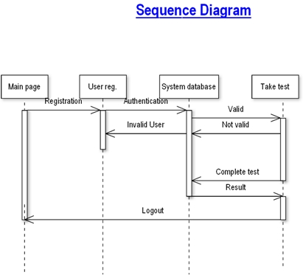

**COLLABORATION DIAGRAM:**

A collaboration diagram is an introduction diagram that emphasizes the structural organization of the objects that send and receive messages. Graphically a collaboration diagram is a collection of vertices and arcs.

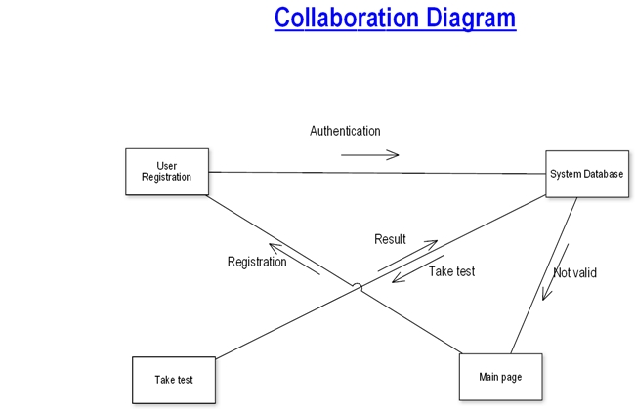

**CLASS DIAGRAM:**

Class is nothing but a structure that contains both variables and methods. The Class Diagram shows a set of classes, interfaces, and collaborations and their relating ships. There is most common diagram in modeling the object oriented systems and are used to give the static view of a system. It shows the dependency between the classes that can be used in our system.

The interactions between the modules or classes of our projects are shown below. Each block contains Class Name, Variables and Methods.

**CLASS:**

A description of set of objects that share the same attributes, operations, relationships, and semantics



**State Chart Diagram**

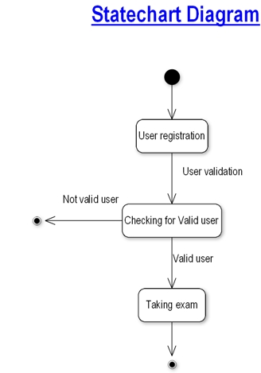

.

**DATA FLOW DIAGRAMS**:

The DFD takes an input-process-output view of a system i.e. data objects flow into the software, are transformed by processing elements, and resultant data objects flow out of the software.

Data objects represented by labeled arrows and transformation are represented by circles also called as bubbles. DFD is presented in a hierarchical fashion i.e. the first data flow model represents the system as a whole. Subsequent DFD refine the context diagram (level 0 DFD), providing increasing details with each subsequent level.

The DFD enables the software engineer to develop models of the information domain & functional domain at the same time. As the DFD is refined into greater levels of details, the analyst perform an implicit functional decomposition of the system. At the same time, the DFD refinement results in a corresponding refinement of the data as it moves through the process that embody the applications.

A context-level DFD for the system the primary external entities produce information for use by the system and consume information generated by the system. The labeled arrow represents data objects or object hierarchy.

**RULES FOR DFD:**

* Fix the scope of the system by means of context diagrams.
* Organize the DFD so that the main sequence of the actions
* Reads left to right and top to bottom.
* Identify all inputs and outputs.
* Identify and label each process internal to the system with Rounded circles.
* A process is required for all the data transformation and Transfers. Therefore, never connect a data store to a data Source or the destinations or another data store with just a Data flow arrow.
* Do not indicate hardware and ignore control information.
* Make sure the names of the processes accurately convey everything the process is done.
* There must not be unnamed process.
* Indicate external sources and destinations of the data, with Squares.
* Number each occurrence of repeated external entities.
* Identify all data flows for each process step, except simple Record retrievals.
* Label data flow on each arrow.
* Use details flow on each arrow.
* Use the details flow arrow to indicate data movements.

**DATAFLOW DIAGRAMS:**

Database:

User registrationn

Take Test

Database

**user registration**

**User registration**

view user details

Delete user details

Register user

Search for user details

**Taking Test**

**Taking Test**

Start Exam

End Exam

View Result

**E-R Diagrams:**

The Entity-Relationship (ER) model was originally proposed by Peter in 1976 [Chen76] as a way to unify the network and relational database views. Simply stated the ER model is a conceptual data model that views the real world as entities and relationships. A basic component of the model is the Entity-Relationship diagram which is used to visually represents data objects. Since Chen wrote his paper the model has been extended and today it is commonly used for database design For the database designer, the utility of the ER model is:

* it maps well to the relational model. The constructs used in the ER model can easily be transformed into relational tables.
* it is simple and easy to understand with a minimum of training. Therefore, the model can be used by the database designer to communicate the design to the end user.
* In addition, the model can be used as a design plan by the database developer to implement a data model in a specific database management software.

## Connectivity and Cardinality

The basic types of connectivity for relations are: one-to-one, one-to-many, and many-to-many. A *one-to-one* (1:1) relationship is when at most one instance of a entity A is associated with one instance of entity B. For example, "employees in the company are each assigned their own office. For each employee there exists a unique office and for each office there exists a unique employee.

A *one-to-many* (1:N) relationships is when for one instance of entity A, there are zero, one, or many instances of entity B, but for one instance of entity B, there is only one instance of entity A. An example of a 1:N relationships is

a department has many employees

each employee is assigned to one department

A *many-to-many* (M:N) relationship, sometimes called non-specific, is when for one instance of entity A, there are zero, one, or many instances of entity B and for one instance of entity B there are zero, one, or many instances of entity A. The connectivity of a relationship describes the mapping of associated

## ER Notation

There is no standard for representing data objects in ER diagrams. Each modeling methodology uses its own notation. The original notation used by Chen is widely used in academics texts and journals but rarely seen in either CASE tools or publications by non-academics. Today, there are a number of notations used, among the more common are Bachman, crow's foot, and IDEFIX.

All notational styles represent entities as rectangular boxes and relationships as lines connecting boxes. Each style uses a special set of symbols to represent the cardinality of a connection. The notation used in this document is from Martin. The symbols used for the basic ER constructs are:

* **entities** are represented by labeled rectangles. The label is the name of the entity. Entity names should be singular nouns.
* **relationships** are represented by a solid line connecting two entities. The name of the relationship is written above the line. Relationship names should be verbs
* **attributes**, when included, are listed inside the entity rectangle. Attributes which are identifiers are underlined. Attribute names should be singular nouns.
* **cardinality** of many is represented by a line ending in a crow's foot. If the crow's foot is omitted, the cardinality is one.
* **existence** is represented by placing a circle or a perpendicular bar on the line. Mandatory existence is shown by the bar (looks like a 1) next to the entity for an instance is required. Optional existence is shown by placing a circle next to the entity that is optional

**Online Examination System Module**

1. **Admin Module**
2. **Student Module**
3. **Admin Module**
4. Login
5. Access Contact us Page
6. View Test
7. Add Test
8. View Quiz
9. Add Quiz
10. View Subscriber
11. View Registered User
12. View Result
13. **Student Module**
14. Login
15. Signup
16. Quiz (Test)
17. View Result

**DATABASE TABLES:**

USER TABLE

|  |  |  |  |
| --- | --- | --- | --- |
|  |  |  |  |
| C:\Users\Anshu Sharma\Downloads\Screenshot_2020-04-01 localhost 127 0 0 1 onlinetest user phpMyAdmin 4 7 7(1).png  Admin Table  C:\Users\Anshu Sharma\Downloads\Screenshot_2020-04-01 localhost 127 0 0 1 onlinetest admin phpMyAdmin 4 7 7.png |  |  |  |
|  |  |  |  |
| Feedback Table  C:\Users\Anshu Sharma\Downloads\Screenshot_2020-04-01 localhost 127 0 0 1 onlinetest contact phpMyAdmin 4 7 7.png |  |  |  |
|  |  |  |  |
| Qusanstable (Question and Answer Table)  C:\Users\Anshu Sharma\Downloads\Screenshot_2020-04-01 localhost 127 0 0 1 onlinetest queanstable phpMyAdmin 4 7 7.png  Quiz table  C:\Users\Anshu Sharma\Downloads\Screenshot_2020-04-01 localhost 127 0 0 1 onlinetest quiz phpMyAdmin 4 7 7.png |  |  |  |
| Result table  C:\Users\Anshu Sharma\Downloads\Screenshot_2020-04-01 localhost 127 0 0 1 onlinetest result phpMyAdmin 4 7 7.png  Subscriber table  C:\Users\Anshu Sharma\Downloads\Screenshot_2020-04-01 localhost 127 0 0 1 onlinetest subscriber phpMyAdmin 4 7 7.png |  |  |  |
| Test table  C:\Users\Anshu Sharma\Downloads\Screenshot_2020-04-01 localhost 127 0 0 1 onlinetest test phpMyAdmin 4 7 7.png |  |  |  |
|  |  |  |  |
|  |  |  |  |
|  |  |  |  |
|  |  |  |  |
|  |  |  |  |



**TESTING:**

The testing phase is an important part of software development. It is the puterized system will help in automate process of finding errors and missing operations and also a complete verification to determine whether the objectives are met and the user requirements are satisfied.

Software testing is carried out in three steps:

1. The first includes unit testing, where in each module is tested to provide its correctness, validity and also determine any missing operations and to verify whether the objectives have been met. Errors are noted down and corrected immediately. Unit testing is the important and major part of the project. So errors are rectified easily in particular module and program clarity is increased. In this project entire system is divided into several modules and is developed individually. So unit testing is conducted to individual modules.

2. The second step includes Integration testing. It need not be the case, the software whose modules when run individually and showing perfect results, will also show perfect results when run as a whole. The individual modules are clipped under this major module and tested again and verified the results. This is due to poor interfacing, which may results in data being lost across an interface. A module can have inadvertent, adverse effect on any other or on the global data structures, causing serious problems.

3. The final step involves validation and testing which determines which the software functions as the user expected. Here also some modifications were. In the completion of the project it is satisfied fully by the end user.

**Maintenance and environment:**

AS the number of computer based systems, grieve libraries of computer software began to expand. In house developed projects produced tones of thousand soft program source statements. Software products purchased from the outside added hundreds of thousands of new statements. A dark cloud appeared on the horizon. All of these programs, all of those source statements-had to be corrected when false were detected, modified as user requirements changed, or adapted to new hardware that was purchased. These activities were collectively called software Maintenance.

The maintenance phase focuses on change that is associated with error correction, adaptations required as the software's environment evolves, and changes due to enhancements brought about by changing customer requirements. Four types of changes are encountered during the maintenance phase.

Correction

Adaptation

Enhancement

Prevention

**Correction:**

Even with the best quality assurance activities is lightly that the customer will uncover defects in the software. Corrective maintenance changes the software to correct defects.

Maintenance is a set of software Engineering activities that occur after software has been delivered to the customer and put into operation. Software configuration management is a set of tracking and control activities that began when a software project begins and terminates only when the software is taken out of the operation.

We may define maintenance by describing four activities that are undertaken after a program is released for use:

Corrective Maintenance

Adaptive Maintenance

Perfective Maintenance or Enhancement

Preventive Maintenance or reengineering

Only about 20 percent of all maintenance work are spent "fixing mistakes". The remaining 80 percent are spent adapting existing systems to changes in their external environment, making enhancements requested by users, and reengineering an application for use.

ADAPTATION:

Over time, the original environment (E>G., CPU, operating system, business rules, external product characteristics) for which the software was developed is likely to change. Adaptive maintenance results in modification to the software to accommodate change to its external environment.

ENHANCEMENT:

As software is used, the customer/user will recognize additional functions that will provide benefit. Perceptive maintenance extends the software beyond its original function requirements.

PREVENTION :

Computer software deteriorates due to change, and because of this, preventive maintenance, often called software re engineering, must be conducted to enable the software to serve the needs of its end users. In essence, preventive maintenance makes changes to computer programs so that they can be more easily corrected, adapted, and enhanced. Software configuration management (SCM) is an umbrella activity that is applied throughout the software process. SCM activities are developed to

## SOFTWARE METHODOLOGY

The software methodology followed in this project includes the object-oriented methodology and the application system development methodologies. The description of these methodologies is given below.

Application System Development – A Life cycle Approach

Although there are a growing number of applications (such as decision support systems) that should be developed using an experimental process strategy such as prototyping, a significant amount of new development work continue to involve major operational applications of broad scope. The application systems are large highly structured. User task comprehension and developer task proficiency is usually high. These factors suggest a linear or iterative assurance strategy. The most common method for this stage class of problems is a system development life cycle modal in which each stage of development is well defined and has straightforward requirements for deliverables, feedback and sign off. The system development life cycle is described in detail since it continues to be an appropriate methodology for a significant part of new development work.

The basic idea of the system development life cycle is that there is a well-defined process by which an application is conceived and developed and implemented. The life cycle gives structure to a creative process. In order to manage and control the development effort, it is necessary to know what should have been done, what has been done, and what has yet to be accomplished. The phrases in the system development life cycle provide a basis for management and control because they define segments of the

flow of work, which can be identified for managerial purposes and specifies the documents or other deliverables to be produced in each phase.

The phases in the life cycle for information system development are described differently by different writers, but the differences are primarily in the amount of necessity and manner of categorization. There is a general agreement on the flow of development steps and the necessity for control procedures at each stage.

The information system development cycle for an application consists of three major stages.

1)Definition.

2)Development.

3)Installation and operation.

The first stage of the process, which defines the information requirements for a feasible cost effective system. The requirements are then translated into a physical system of forms, procedures, programs etc., by the system design, computer programming and procedure development. The resulting system is test and put into operation. No system is perfect so there is always a need for maintenance changes. To complete the cycle, there should be a post audit of the system to evaluate how well it performs and how well it meets the cost and performance specifications. The stages of definition, development and installation and operation can therefore be divided into smaller steps or phrases as follows.

Definition

Proposed definition : preparation of request for proposed applications.

Feasibility assessment : evaluation of feasibility and cost benefit of proposed system.

Information requirement analysis : determination of information needed.

Design

Conceptual design : User-oriented design of application development.

Physical system design : Detailed design of flows and processes in applications processing system and preparation of program specification.

Development

Program development : coding and testing of computer programs.

Procedure development : design of procedures and preparation of user instructions.

Installation and operation

Conversion : final system test and conversion.

Operation and maintenance : Month to month operation and maintenance

Post audit : Evaluation of development process,application system and results of use at the completion of the each phase, formal approval sign-off is required from the users as well as from the manager of the project development.

Testing is a process of executing a program with the indent of finding an error. Testing is a crucial element of software quality assurance and presents ultimate review of specification, design and coding.

System Testing is an important phase. Testing represents an interesting anomaly for the software. Thus a series of testing are performed for the proposed system before the system is ready for user acceptance testing.

A good test case is one that has a high probability of finding an as undiscovered error. A successful test is one that uncovers an as undiscovered error.

Testing Objectives:

1.Testing is a process of executing a program with the intent of finding an error

2.A good test case is one that has a probability of finding an as yet undiscovered error

3.A successful test is one that uncovers an undiscovered error

Testing Principles

1. All tests should be traceable to end user requirements

2.Tests should be planned long before testing begins

3.Testing should begin on a small scale and progress towards testing in large

4.Exhaustive testing is not possible

5.To be most effective testing should be conducted by a independent third party

The primary objective for test case design is to derive a set of tests that has the highest livelihood for uncovering defects in software. To accomplish this objective two different categories of test case design techniques are used. They are

White box testing.

Black box testing.

# White-box testing:

White box testing focus on the program control structure. Test cases are derived to ensure that all statements in the program have been executed at least once during testing and that all logical conditions have been executed.

# Block-box testing:

Black box testing is designed to validate functional requirements without regard to the internal workings of a program. Black box testing mainly focuses on the information domain of the software, deriving test cases by partitioning input and output in a manner that provides through test coverage. Incorrect and missing functions, interface errors, errors in data structures, error in functional logic are the errors falling in this category.

Testing strategies:

A strategy for software testing must accommodate low-level tests that are necessary to verify that all small source code segment has been correctly implemented as well as high-level tests that validate major system functions against customer requirements.

Testing fundamentals:

Testing is a process of executing program with the intent of finding error. A good test case is one that has high probability of finding an undiscovered error. If testing is conducted successfully it uncovers the errors in the software. Testing cannot show the absence of defects, it can only show that software defects present.

Testing Information flow:

Information flow for testing flows the pattern. Two class of input provided to test the process. The software configuration includes a software requirements specification, a design specification and source code.

Test configuration includes test plan and test cases and test tools. Tests are conducted and all the results are evaluated. That is test results are compared with expected results. When erroneous data are uncovered, an error is implied and debugging commences.

Unit testing:

Unit testing is essential for the verification of the code produced during the coding phase and hence the goal is to test the internal logic of the modules. Using the detailed design description as a guide, important paths are tested to uncover errors with in the boundary of the modules. These tests were carried out during the programming stage itself. All units of ViennaSQL were successfully tested.

Integration testing :

Integration testing focuses on unit tested modules and build the program structure that is dictated by the design phase.

System testing:

System testing tests the integration of each module in the system. It also tests to find discrepancies between the system and it’s original objective, current specification and system documentation. The primary concern is the compatibility of individual modules. Entire system is working properly or not will be tested here, and specified path ODBC connection will correct or not, and giving output or not are tested here these verifications and validations are done by giving input values to the system and by comparing with expected output. Top-down testing implementing here.

## Acceptance Testing:

This testing is done to verify the readiness of the system for the implementation. Acceptance testing begins when the system is complete. Its purpose is to provide the end user with the confidence that the system is ready for use. It involves planning and execution of functional tests, performance tests and stress tests in order to demonstrate that the implemented system satisfies its requirements.

Tools to special importance during acceptance testing include:

Test coverage Analyzer – records the control paths followed for each test case.

Timing Analyzer – also called a profiler, reports the time spent in various regions of the code are areas to concentrate on to improve system performance.

Coding standards – static analyzers and standard checkers are used to inspect code for deviations from standards and guidelines.

Coding

1. **Index.php**

<?php

session\_start();

?>

<!DOCTYPE html>

<html lang="zxx">

<head>

<?php

include('bootstrapFiles.php');

?>

</head>

<body>

<?php

include('navigation.php');

?>

</header>

<!-- //header -->

<div class="container">

<!-- banner-text -->

<div class="banner-text">

<div class="slider-info">

<h3>What would <span>you like </span> to Do!?</h3>

</div>

</div>

</div>

</div>

<!-- //banner-text -->

<!--banner form-->

<section class="banner\_form py-5">

<div class="container py-lg-3">

<div class="row ban\_form">

<div class="col-lg-8 bg-white fom-left">

<div class="categories\_sub cats1">

<h2 class="heading-agileinfo">Welcome To <span> Tests </span></h2>

<p class="vam">Online examination is conducting a test online to measure the knowledge of the participants on a given topic. In the olden days, everybody had to gather in a classroom at the same time to take an exam. </p></div>

</div>

<div class="col-lg-4 reg-fom">

<h4 class="text-white text-center">Sign Up</h4>

<form action="#" method="post">

<div class="reg-fom-btm mt-5">

<div class="fields">

<input type="text" name="name" placeholder="Name" class="form-control">

</div>

</div>

<div class="reg-fom-btm mt-3">

<div class="fields">

<input type="text" name="college" placeholder="College" class="form-control">

</div>

</div>

<div class="reg-fom-btm mt-3">

<div class="fields">

<input type="text" name="contact" placeholder="Contact" class="form-control">

</div>

</div>

<div class="reg-fom-btm mt-3">

<div class="fields">

<input type="text" name="email" placeholder="Email" class="form-control">

</div>

</div>

<div class="reg-fom-btm mt-3">

<div class="fields">

<input type="password" name="pwd" placeholder="password" class="form-control">

</div>

</div>

<div class="reg-fom-btm mt-3">

<div class="fields">

<input type="password" name="cpwd" placeholder="Confirm Password" class="form-control">

</div>

</div>

<div class="reg-fom-btm mt-3">

<input type="submit"name="signup" value="Signup">

</div>

</form>

<?php

if(isset($\_POST['signup']))

{

extract($\_POST);

$con = mysqli\_connect("localhost","root","","onlinetest");

$sqlquery = "SELECT 1 FROM `user` WHERE email = '$email'";

$select\_result = mysqli\_query($con,$sqlquery);

if(mysqli\_num\_rows($select\_result)>0)

{

echo "<script>alert('Email is already Exists')</script>";

}

else if($pwd != $cpwd)

{

echo "<script>alert('Password are not match')</script>";

}

else

{

$insert = mysqli\_query($con,"INSERT INTO `user`(`Name`, `College`, `Contact`, `Email`, `Confirm`) VALUES ('$name','$college','$contact','$email','$cpwd')");

if($insert == true)

{

echo "<script>alert('Signup Successfully!!');</script>";

}

else

{

echo "<script>alert('Not Inserted !!');</script>";

}

}

}

?>

</div>

</div>

</div>

</section>

<!--//banner form-->

<!-- /services -->

<section class="banner-bottom-wthree py-lg-5 py-md-5 py-3">

<div class="container">

<div class="inner-sec-w3ls py-lg-5 py-3">

<h3 class="heading-agileinfo text-center">What <span> We do</span></h3>

<div class="row middle-grids mt-md-5 pt-4">

<?php

$con = mysqli\_connect("localhost","root","","onlinetest");

$res = mysqli\_query($con,"SELECT \* FROM `test`");

while($row =mysqli\_fetch\_array($res))

{

?>

<div class="col-lg-4 about-in-w3ls middle-grid-info text-center">

<div class="card">

<div class="card-body">

<i class="fas fa-graduation-cap mb-2"></i>

<h5 class="card-title text-uppercase my-3">

<?php echo $row['Test Heading'];?></h5>

<p class="card-text"><?php echo $row['Test Description'];?>

</p>

</div>

</div>

</div>

<?php

}

?>

</div>

</div>

</div>

</section>

<!-- //services -->

<!-- choose -->

<section class="choose py-5">

<div class="container py-md-4 mt-md-3">

<div class="row inner\_w3l\_agile\_grids-1 ">

<div class="col-lg-6 w3layouts\_choose\_left\_grid1">

<div class="choose\_top">

<h4 class="mb-3 mt-3 text-white">Build Your Career with us </h4>

<p class="text-white">With online examination students can do the exam online, in their own time, with their own device, regardless of where they live. You only need a browser and an internet connection. </p>

</div>

</div>

<div class="col-lg-6 w3layouts\_choose\_left\_grid2">

<div class="row">

<div class="col-md-6 w3l\_choose\_bottom1 mt-3 pt-md-4">

<div class="choose\_bottom\_top">

<i class="fas fa-globe mb-2"></i>

<h5 class="card-title text-uppercase my-3">General Tests</h5>

<p class="card-text">Aptitude, Reasoning and English etc.

</p>

</div>

</div>

<div class="col-md-6 w3l\_choose\_bottom3 mt-3 pt-md-4">

<div class="choose\_bottom\_top">

<i class="fas fa-graduation-cap mb-2"></i>

<h5 class="card-title text-uppercase my-3">Programming Tests</h5>

<p class="card-text">C, C++, Java, PHP and Python etc.

</p>

</div>

</div>

<div class="col-md-6 w3l\_choose\_bottom4">

<div class="choose\_bottom\_top">

<i class="fas fa-globe mb-2"></i>

<h5 class="card-title text-uppercase my-3">Technical Tests</h5>

<p class="card-text">Computer Networks, Database etc.

</p>

</div>

</div>

</div>

</div>

</div>

</div>

</section>

<!-- //choose -->

<!-- stats -->

<section class="stats py-5">

<div class="container py-md-5">

<h3 class="heading-agileinfo text-center">Our <span>Achievements</span></h3>

<span class="w3-line black"></span>

<div class="row inner\_w3l\_agile\_grids-1 pt-md-5 mt-4">

<div class="col-lg-3 col-sm-6 w3layouts\_stats\_left w3\_counter\_grid">

<i class="fas fa-trophy mb-2"></i>

<p class="counter">2010</p>

<h3>Year of Foundation</h3>

</div>

<div class="col-lg-3 col-sm-6 w3layouts\_stats\_left w3\_counter\_grid1">

<i class="fas fa-graduation-cap mb-2"></i>

<p class="counter">765</p>

<h3>Qualified</h3>

</div>

<div class="col-lg-3 col-sm-6 w3layouts\_stats\_left w3\_counter\_grid2">

<i class="fas fa-user mb-2"></i>

<p class="counter">125</p>

<h3>Selected Candidate</h3>

</div>

<div class="col-lg-3 col-sm-6 w3layouts\_stats\_left w3\_counter\_grid2">

<i class="fas fa-users mb-2"></i>

<p class="counter">1500</p>

<h3>Registered Candidate</h3>

</div>

</div>

</div>

</section>

<!-- //stats -->

<!--/newsletter-->

<?php

include('footer.php');

?>

1. **BootstrapFiles.php**

<title>Online Examination System</title>

<meta name="viewport" content="width=device-width, initial-scale=1">

<meta charset="utf-8" />

<meta name="keywords" content="Subject Responsive web template, Bootstrap Web Templates, Flat Web Templates, Android Compatible web template,

SmartPhone Compatible web template, free WebDesigns for Nokia, Samsung, LG, Sony Ericsson, Motorola web design" />

<script>

addEventListener("load", function () {

setTimeout(hideURLbar, 0);

}, false);

function hideURLbar() {

window.scrollTo(0, 1);

}

</script>

<!-- Custom Theme files -->

<link href="css/bootstrap.css" type="text/css" rel="stylesheet" media="all">

<link href="css/style.css" type="text/css" rel="stylesheet" media="all">

<!-- gallery smoothbox -->

<link rel="stylesheet" href="css/smoothbox.css" type='text/css' media="all" />

<!-- font-awesome icons -->

<link href="css/fontawesome-all.min.css" rel="stylesheet">

<!-- //Custom Theme files -->

<!-- online-fonts -->

<link href="//fonts.googleapis.com/css?family=Roboto:100i,400,500,700" rel="stylesheet">

<link href="//fonts.googleapis.com/css?family=Montserrat:300,400,500,600,700,800" rel="stylesheet">

<!-- //online-fonts -->

**3 – Change.php**

<?php

include('bootstrapFiles.php');

?>

<!DOCTYPE html>

<html lang="zxx">

<head>

<title>Online Examination System</title>

</head>

<body>

<!-- banner -->

<div class="inner-banner">

<!-- header -->

<header>

<nav class="navbar navbar-expand-lg navbar-light bg-gradient-secondary pt-3">

<h1><a class="navbar-brand" href="index.html">Online Examination System

<span>Test Yourself!!</span>

</a></h1>

<button class="navbar-toggler ml-md-auto" type="button" data-toggle="collapse" data-target="#navbarSupportedContent" aria-controls="navbarSupportedContent"

aria-expanded="false" aria-label="Toggle navigation">

<span class="navbar-toggler-icon"></span>

</button>

<div class="collapse navbar-collapse" id="navbarSupportedContent">

<ul class="navbar-nav ml-auto">

<li class="nav-item">

<a class="nav-link" href="index.php">Home

<span class="sr-only">(current)</span>

</a>

</li>

<li class="nav-item active mx-xl-4 mx-lg-3 my-lg-0 my-3">

<a class="nav-link" href="about.php">About Us</a>

</li>

<li class="nav-item">

<a class="nav-link" href="contact.php">Contact Us</a>

</li>

</ul>

</div>

</nav>

</div>

<!--/newsletter-->

<br><br><br><br>

<div class="container">

<div class="row">

<div class="col-lg-8 m-auto d-block">

<center><h2>Change Password</h2></center>

<br>

<form method="post" >

<div class="input-group mb-3">

<div class="input-group-append">

<span class="input-group-text">Email</span>

</div>

<input type="email" name="email" class="form-control">

</div>

<div class="input-group mb-3">

<div class="input-group-append">

<span class="input-group-text">Last Password</span>

</div>

<input type="password" name="lpwd" class="form-control">

</div>

<div class="input-group mb-3">

<div class="input-group-append">

<span class="input-group-text">New Password</span>

</div>

<input type="password" name="password" class="form-control">

</div>

<input type="submit" name="submit" value="Change" class="btn btn-success col-sm-3 col-sm-6 col-sm-12">

</form>

</div>

</div>

</div>

<?php

if(isset($\_POST['submit']))

{

$email = $\_POST['email'];

$lpwd = $\_POST['lpwd'];

$password = $\_POST['password'];

$con = mysqli\_connect("localhost","root","","onlinetest");

$res = mysqli\_query($con,"SELECT \* FROM `admin` ");

$row = mysqli\_fetch\_array($res);

echo $row['Password'];

if($lpwd == $row['Password'])

{

$update = mysqli\_query($con,"UPDATE `admin` SET `Password`='$password' WHERE `Email` = '$email'");

if($update == true)

{

echo "<script>alert('Your Password is Change Successfully!!!');window.location='index.php'</script>";

}

else

{

echo "<script>alert('Problem in changing Password!!!')</script>";

}

}

}

?>

**4 – Changepwd.php (User Change his/her Password)**

<?php

include('bootstrapFiles.php');

?>

<!DOCTYPE html>

<html lang="zxx">

<head>

<title>Online Examination System</title>

</head>

<body>

<!-- banner -->

<div class="inner-banner">

<!-- header -->

<header>

<nav class="navbar navbar-expand-lg navbar-light bg-gradient-secondary pt-3">

<h1><a class="navbar-brand" href="index.html">Online Examination System

<span>Test Yourself!!</span>

</a></h1>

<button class="navbar-toggler ml-md-auto" type="button" data-toggle="collapse" data-target="#navbarSupportedContent" aria-controls="navbarSupportedContent"

aria-expanded="false" aria-label="Toggle navigation">

<span class="navbar-toggler-icon"></span>

</button>

<div class="collapse navbar-collapse" id="navbarSupportedContent">

<ul class="navbar-nav ml-auto">

<li class="nav-item">

<a class="nav-link" href="index.php">Home

<span class="sr-only">(current)</span>

</a>

</li>

<li class="nav-item active mx-xl-4 mx-lg-3 my-lg-0 my-3">

<a class="nav-link" href="about.php">About Us</a>

</li>

<li class="nav-item">

<a class="nav-link" href="contact.php">Contact Us</a>

</li>

</ul>

</div>

</nav>

</div>

<!--/newsletter-->

<br><br><br><br>

<div class="container">

<div class="row">

<div class="col-lg-8 m-auto d-block">

<center><h2>Change Password</h2></center>

<br>

<form method="post" >

<div class="input-group mb-3">

<div class="input-group-append">

<span class="input-group-text">Email</span>

</div>

<input type="email" name="email" class="form-control">

</div>

<div class="input-group mb-3">

<div class="input-group-append">

<span class="input-group-text">Last Password</span>

</div>

<input type="password" name="lpwd" class="form-control">

</div>

<div class="input-group mb-3">

<div class="input-group-append">

<span class="input-group-text">New Password</span>

</div>

<input type="password" name="password" class="form-control">

</div>

<input type="submit" name="submit" value="Change" class="btn btn-success col-sm-3 col-sm-6 col-sm-12">

</form>

</div>

</div>

</div>

<?php

if(isset($\_POST['submit']))

{

$email = $\_POST['email'];

$lpwd = $\_POST['lpwd'];

$password = $\_POST['password'];

$con = mysqli\_connect("localhost","root","","onlinetest");

$res = mysqli\_query($con,"SELECT \* FROM `admin` ");

$row = mysqli\_fetch\_array($res);

echo $row['Password'];

if($lpwd == $row['Password'])

{

$update = mysqli\_query($con,"UPDATE `admin` SET `Password`='$password' WHERE `Email` = '$email'");

if($update == true)

{

echo "<script>alert('Your Password is Change Successfully!!!');window.location='index.php'</script>";

}

else

{

echo "<script>alert('Problem in changing Password!!!')</script>";

}

}

}

?>

**5 – Check.php**

<?php

session\_start();

error\_reporting(0);

?>

<html>

<html>

<head>

<title>Online Examination System</title>

<!-- Bootstrap Core CSS -->

<link href="css/bootstrap.css" rel='stylesheet' type='text/css' />

<!-- Custom CSS -->

<link href="css/style.css" rel='stylesheet' type='text/css' />

<!-- font-awesome icons CSS -->

<link href="css/font-awesome.css" rel="stylesheet">

<!-- //font-awesome icons CSS-->

<!-- side nav css file -->

<link href='css/SidebarNav.min.css' media='all' rel='stylesheet' type='text/css'/>

<!-- //side nav css file -->

<!-- js-->

<script src="js/jquery-1.11.1.min.js"></script>

<script src="js/modernizr.custom.js"></script>

<!--webfonts-->

<link href="//fonts.googleapis.com/css?family=PT+Sans:400,400i,700,700i&amp;subset=cyrillic,cyrillic-ext,latin-ext" rel="stylesheet">

<!--//webfonts-->

<!-- chart -->

<script src="js/Chart.js"></script>

<!-- //chart -->

<!-- Metis Menu -->

<script src="js/metisMenu.min.js"></script>

<script src="js/custom.js"></script>

<link href="css/custom.css" rel="stylesheet">

<!--//Metis Menu -->

<style>

#chartdiv {

width: 100%;

height: 295px;

}

</style>

<!--pie-chart --><!-- index page sales reviews visitors pie chart -->

<script src="js/pie-chart.js" type="text/javascript"></script>

<script type="text/javascript">

$(document).ready(function () {

$('#demo-pie-1').pieChart({

barColor: '#2dde98',

trackColor: '#eee',

lineCap: 'round',

lineWidth: 8,

onStep: function (from, to, percent) {

$(this.element).find('.pie-value').text(Math.round(percent) + '%');

}

});

$('#demo-pie-2').pieChart({

barColor: '#8e43e7',

trackColor: '#eee',

lineCap: 'butt',

lineWidth: 8,

onStep: function (from, to, percent) {

$(this.element).find('.pie-value').text(Math.round(percent) + '%');

}

});

$('#demo-pie-3').pieChart({

barColor: '#ffc168',

trackColor: '#eee',

lineCap: 'square',

lineWidth: 8,

onStep: function (from, to, percent) {

$(this.element).find('.pie-value').text(Math.round(percent) + '%');

}

});

});

</script>

<!-- //pie-chart --><!-- index page sales reviews visitors pie chart -->

<!-- requried-jsfiles-for owl -->

<link href="css/owl.carousel.css" rel="stylesheet">

<script src="js/owl.carousel.js"></script>

<script>

$(document).ready(function() {

$("#owl-demo").owlCarousel({

items : 3,

lazyLoad : true,

autoPlay : true,

pagination : true,

nav:true,

});

});

</script>

<!-- //requried-jsfiles-for owl -->

</head>

<body>

<?php

$email = $\_SESSION['email'];

$password = $\_SESSION['password'];

$con = mysqli\_connect("localhost","root","","onlinetest");

$res = mysqli\_query($con,"SELECT \* FROM `user` WHERE `Email` = '$email' and `Confirm` = '$password'");

$row = mysqli\_fetch\_array($res);

$name = $row['Name'];

?>

<?php

if(isset($\_POST['submit']))

{

$subject = $\_SESSION['Title'];

$checked = $\_POST['quizcheck'];

$con = mysqli\_connect("localhost","root","","onlinetest");

$result = mysqli\_query($con,"SELECT \* FROM `queanstable` WHERE `Category`= '$subject' ");

$total = 0;

while($row = mysqli\_fetch\_array($result))

{

$i= $row['ID'];

if($checked[$i] == $row['rightAns'])

{

$total++;

}

$i++;

}

$insert = mysqli\_query($con,"INSERT INTO `result`(`Name`, `Email`, `Subject`, `Marks`) VALUES ('$name','$email','$subject','$total')");

}

?> <br><br><br><br><br><br><br><br>

<div class="container">

<div class="jumbotron">

<h1>You Have Successfully Submitted your <?php echo $subject ?> Test.</h1>

<br><br><br>

<a href="index.php" class="btn btn-primary">Go Back</a>

</div>

</div>

</body>

</html>

**6- Feedback.php**

<!DOCTYPE html>

<html lang="zxx">

<head>

<title>Online Examination System</title>

<?php

include('bootstrapFiles.php');

?>

</head>

<body>

<?php

include('navigation.php');

?>

<br><br><br><br><br>

<div class="col-md-6 main\_grid\_contact m-auto d-block">

<div class="form">

<h4 class="mb-4 text-left">Give Feedback</h4>

<form method="post">

<div class="form-group">

<label class="my-2">Name</label>

<input class="form-control" type="text" name="Name" placeholder="Name" required="">

</div>

<div class="form-group">

<label>Email</label>

<input class="form-control" type="email" name="Email" placeholder="example@gmail.com" required="">

</div>

<div class="form-group">

<label>Contact</label>

<input class="form-control" type="tel" name="Contact" placeholder="+91 \*\*\*\*\*\*\*\*\*\*" required="">

</div>

<div class="form-group">

<label>Feedback</label>

<textarea name ="msg" id="textarea" placeholder="Write Feedback Here!"></textarea>

</div>

<div class="input-group1">

<input class="form-control" type="submit" name="feedback" value="Send Feedback">

</div>

</form>

</div>

</div>

</div>

</div>

</div>

</section>

<?php

if(isset($\_POST['feedback']))

{

extract($\_POST);

$con = mysqli\_connect("localhost","root","","onlinetest");

$insert = mysqli\_query($con,"INSERT INTO `contact`(`Name`, `Email`, `Contact`, `Message`) VALUES ('$Name','$Email','$Contact','$msg')");

if($insert == true)

{

echo "<script>alert('Your Feedback Submitted Successfully!!');window.location='index.php'</script>";

}

else

{

echo "<script>alert('Not Inserted !!');</script>";

}

}

?>

<!-- //contact -->

<!--/newsletter-->

<?php

include('footer.php');

?>

**7- footer.php**

<footer class="newsletter\_right pymd-5 py-4" id="footer">

<div class="container">

<div class="inner-sec py-md-5 py-3">

<div class="row mb-md-4 mb-md-3">

<div class="col-lg-3 col-md-6 social-info text-left">

<h3 class="tittle1 foot mb-md-5 mb-4 text-white">Get in touch</h3>

<p>Lucknow Uttar Pradesh </p>

<p class="my-2"> Lucknow Uttar Pradesh</p>

<p class="phone">phone: 7007976332</p>

<p class="phone">Mail:

<a href="mailto:info@example.com">anshusharma1298@gmail</a>

</p>

</div>

<div class="col-lg-3 col-md-6 social-info text-left">

<h3 class="tittle1 foot mb-md-5 mb-4 text-white">About Us</h3>

<p>Online examination is conducting a test online to measure the knowledge of the participants on a given topic. In the olden days, everybody had to gather in a classroom at the same time to take an exam. </p>

</div>

<div class="col-lg-6 col-md-12 n-right tex-left">

<h3 class="tittle1 foot mb-md-5 mb-4 text-white">Subscribe our Newsletter</h3>

<form method="post">

<div class="form-group d-flex">

<input class="form-control" type="email" name="Email" placeholder=" Email Address" required="">

<input class="form-control submit text-uppercase" name="submit" type="submit" value="Subscribe">

</div>

</form>

<?php

if(isset($\_POST['submit']))

{

extract($\_POST);

$con = mysqli\_connect("localhost","root","","onlinetest");

$insert = mysqli\_query($con,"INSERT INTO `subscriber`(`Email`) VALUES ('$Email')");

if($insert == true)

{

echo "<script>alert('Thanks for Subscribing us!!');</script>";

}

else

{

echo "<script>alert('Not Inserted !!');</script>";

}

}

?>

</div>

</div>

</div>

</div>

</footer>

<div class="copyright py-3">

<div class="container">

<div class="row">

<div class="col-md-8">

<p class="copy-right mt-2">© 2018 Subject. All Rights Reserved | Design by

<a href="#">Anshu Sharma</a>&nbsp &nbsp &nbsp &nbsp &nbsp &nbsp &nbsp &nbsp &nbsp &nbsp &nbsp

<a href="Login.php">Admin Login</a>

</p>

</div>

<div class="col-md-4">

<ul class="social-icons scial justify-content-end">

<li class="mr-1"><a href="#"><span class="fab fa-facebook-f"></span></a></li>

<li class="mx-1"><a href="#"><span class="fab fa-twitter"></span></a></li>

<li class="mx-1"><a href="#"><span class="fab fa-google-plus-g"></span></a></li>

<li class="mx-1"><a href="#"><span class="fab fa-linkedin-in"></span></a></li>

</ul>

</div>

</div>

</div>

</div>

<!--//newsletter-->

<!-- js -->

<script src="js/jquery-2.2.3.min.js"></script>

<!-- //js -->

<!-- carousel(for feedback) -->

<script src="js/owl.carousel.js"></script>

<script>

$(document).ready(function () {

$('.owl-carousel').owlCarousel({

loop: true,

margin: 10,

responsiveClass: true,

responsive: {

0: {

items: 1,

nav: true

},

600: {

items: 2,

nav: false

},

1000: {

items: 3,

nav: true,

loop: false,

margin: 20

}

}

})

})

</script>

<!-- //carousel(for feedback) -->

<!-- stats -->

<script src="js/jquery.waypoints.min.js"></script>

<script src="js/jquery.countup.js"></script>

<script>

$('.counter').countUp();

</script>

<!-- //stats -->

<!-- start-smooth-scrolling -->

<script src="js/move-top.js"></script>

<script src="js/easing.js"></script>

<script>

jQuery(document).ready(function ($) {

$(".scroll").click(function (event) {

event.preventDefault();

$('html,body').animate({

scrollTop: $(this.hash).offset().top

}, 1000);

});

});

</script>

<!-- //end-smooth-scrolling -->

<!-- smooth-scrolling-of-move-up -->

<script>

$(document).ready(function () {

/\*

var defaults = {

containerID: 'toTop', // fading element id

containerHoverID: 'toTopHover', // fading element hover id

scrollSpeed: 1200,

easingType: 'linear'

};

\*/

$().UItoTop({

easingType: 'easeOutQuart'

});

});

</script>

<script src="js/SmoothScroll.min.js"></script>

<!-- //smooth-scrolling-of-move-up -->

<!-- Bootstrap core JavaScript

================================================== -->

<!-- Placed at the end of the document so the pages load faster -->

<script src="js/bootstrap.js"></script>

</body>

</html>

<?php

if(isset($\_POST['login']))

{

// username and password sent from form

$db=mysqli\_connect("localhost","root","","onlinetest");

$myusername = mysqli\_real\_escape\_string($db,$\_POST['email']);

$mypassword = mysqli\_real\_escape\_string($db,$\_POST['password']);

$\_SESSION['email'] = $myusername;

$\_SESSION['password'] =$mypassword;

$sql = "SELECT \* FROM `user` WHERE `Email` = '$myusername' and `Confirm` = '$mypassword' ";

$result = mysqli\_query($db,$sql);

$row = mysqli\_fetch\_array($result,MYSQLI\_ASSOC);

$count = mysqli\_num\_rows($result);

// If result matched $myusername and $mypassword, table row must be 1 row

if($count == 1)

{

echo "<script>window.location='TestCategory.php'</script>";

}else {

echo "<script>alert('Your Email or Password is invalid or You are not Registered')</script>";

}

}

?>

**8- Login.php**

<?php

include('bootstrapFiles.php');

?>

<!DOCTYPE html>

<html lang="zxx">

<head>

<title>Online Examination System</title>

</head>

<body>

<!-- banner -->

<div class="inner-banner">

<!-- header -->

<header>

<nav class="navbar navbar-expand-lg navbar-light bg-gradient-secondary pt-3">

<h1><a class="navbar-brand" href="index.html">Online Examination System

<span>Test Yourself!!</span>

</a></h1>

<button class="navbar-toggler ml-md-auto" type="button" data-toggle="collapse" data-target="#navbarSupportedContent" aria-controls="navbarSupportedContent"

aria-expanded="false" aria-label="Toggle navigation">

<span class="navbar-toggler-icon"></span>

</button>

<div class="collapse navbar-collapse" id="navbarSupportedContent">

<ul class="navbar-nav ml-auto">

<li class="nav-item">

<a class="nav-link" href="index.php">Home

<span class="sr-only">(current)</span>

</a>

</li>

<li class="nav-item active mx-xl-4 mx-lg-3 my-lg-0 my-3">

<a class="nav-link" href="Login.php">Login </a>

</li>

</ul>

</div>

</nav>

</div>

<!--/newsletter-->

<br><br><br><br>

<div class="container">

<div class="row">

<div class="col-lg-8 m-auto d-block">

<center><h2>Admin Login </h2></center>

<br>

<form method="post" >

<div class="input-group mb-3">

<div class="input-group-append">

<span class="input-group-text">Email</span>

</div>

<input type="email" name="email" class="form-control">

</div>

<div class="input-group mb-3">

<div class="input-group-append">

<span class="input-group-text">Password</span>

</div>

<input type="password" name="password" class="form-control">

</div>

<input type="submit" name="signin" value="Login" class="btn btn-success col-sm-3 col-sm-6 col-sm-12">

</form>

<a href="change.php" style="text-decoration:none; float:left;color">Change Password?</a>

</div>

</div>

</div>

<?php

if(isset($\_POST['signin']))

{

// username and password sent from form

$db=mysqli\_connect("localhost","root","","onlinetest");

$myusername = mysqli\_real\_escape\_string($db,$\_POST['email']);

$mypassword = mysqli\_real\_escape\_string($db,$\_POST['password']);

$\_SESSION['email'] = $myusername;

$\_SESSION['password'] =$mypassword;

$sql = "SELECT \* FROM `admin` WHERE `Email` = '$myusername' and `Password` = '$mypassword' ";

$result = mysqli\_query($db,$sql);

$row = mysqli\_fetch\_array($result,MYSQLI\_ASSOC);

$count = mysqli\_num\_rows($result);

// If result matched $myusername and $mypassword, table row must be 1 row

if($count == 1)

{

echo "<script>window.location='Admin/index.php'</script>";

}

else

{

echo "<script>alert('Your Email or Password is invalid or You are not Registered')</script>";

}

}

?>

**9- Navigation.php**

<!-- banner -->

<div class="banner">

<!-- header -->

<header>

<nav class="navbar navbar-expand-lg navbar-light bg-gradient-secondary pt-3">

<h1><a class="navbar-brand" href="index.html">Online Examination System

<span>Test Yourself!!</span>

</a></h1>

<button class="navbar-toggler ml-md-auto" type="button" data-toggle="collapse" data-target="#navbarSupportedContent" aria-controls="navbarSupportedContent"

aria-expanded="false" aria-label="Toggle navigation">

<span class="navbar-toggler-icon"></span>

</button>

<div class="collapse navbar-collapse" id="navbarSupportedContent">

<ul class="navbar-nav ml-auto">

<li class="nav-item active">

<a class="nav-link" href="index.php">Home

<span class="sr-only">(current)</span>

</a>

</li>

<li class="nav-item mx-xl-4 mx-lg-3 my-lg-0 my-3">

<a class="nav-link" href="index.php" data-toggle="modal" data-target="#myModal">Signin</a>

</li>

<li class="nav-item mx-xl-4 mx-lg-3 my-lg-0 my-3">

<a class="nav-link" href="index.php" data-toggle="modal" data-target="#ResultModal">Result</a>

</li>

<li class="nav-item mx-xl-4 mx-lg-3 my-lg-0 my-3">

<a class="nav-link" href="index.php" data-toggle="modal" data-target="#DevModal">Developer</a>

</li>

<li class="nav-item mx-xl-4 mx-lg-3 my-lg-0 my-3">

<a class="nav-link" href="Feedback.php">Feedback</a>

</li>

</ul>

</div>

</nav>

<!--Login Modal-->

<div class="modal" id="myModal">

<div class="modal-dialog">

<div class="modal-content">

<!-- Modal Header -->

<div class="modal-header">

<h4 class="modal-title">Login </h4>

<button type="button" class="close" data-dismiss="modal">&times;</button>

</div>

<!-- Modal body -->

<div class="modal-body">

<form method="post" >

<div class="input-group mb-3">

<div class="input-group-append">

<span class="input-group-text">Email</span>

</div>

<input type="email" name="email" class="form-control">

</div>

<div class="input-group mb-3">

<div class="input-group-append">

<span class="input-group-text">Password</span>

</div>

<input type="password" name="password" class="form-control">

</div>

<input type="submit" name="login" value="Login" class="btn btn-success col-sm-3 col-sm-6 col-sm-12">

</form>

<a href="changepwd.php" style="text-decoration:none; float:left;color">Change Password?</a>

</div>

<!-- Modal footer -->

<div class="modal-footer">

<button type="button" class="btn btn-danger" data-dismiss="modal">Close</button>

</div>

</div>

</div>

</div>

<!--Result Modal-->

<div class="modal" id="ResultModal">

<div class="modal-dialog">

<div class="modal-content">

<!-- Modal Header -->

<div class="modal-header">

<h4 class="modal-title">Result</h4>

<button type="button" class="close" data-dismiss="modal">&times;</button>

</div>

<!-- Modal body -->

<div class="modal-body">

<form method="post" >

<div class="input-group mb-3">

<div class="input-group-append">

<span class="input-group-text">Email</span>

</div>

<input type="email" name="email" class="form-control">

</div>

<input type="submit" name="result" value="View Result" class="btn btn-success col-sm-3 col-sm-6 col-sm-12">

</form>

<?php

if(isset($\_POST['result']))

{

$email = $\_POST['email'];

$\_SESSION['email'] = $email;

echo "<script>window.location='Result.php'</script>";

}

?>

</table>

</div>

<!-- Modal footer -->

<div class="modal-footer">

<button type="button" class="btn btn-danger" data-dismiss="modal">Close</button>

</div>

</div>

</div>

</div>

<!--Developer Modal-->

<!-- The Modal -->

<div class="modal" id="DevModal">

<div class="modal-dialog">

<div class="modal-content">

<!-- Modal Header -->

<div class="modal-header">

<h4 class="modal-title">Developer</h4>

<button type="button" class="close" data-dismiss="modal">&times;</button>

</div>

<!-- Modal body -->

<div class="modal-body">

<div class="row">

<div class="col-sm-5">

<img src="images/anshu.jpg" height="200px" width="150px" class="rounded">

</div>

<div class="col-sm-5">

<p>

<h6>Anshu Sharma</h6>

<h6>anshusharma1298@gmail.com</h6>

<h6>7007976332</h6>

<h6>Shri Ramswaroop Memorial University </h6>

</p>

</div>

</div>

</div>

<!-- Modal footer -->

<div class="modal-footer">

<button type="button" class="btn btn-danger" data-dismiss="modal">Close</button>

</div>

</div>

</div>

</div>

<!--End of the Developer Modal-->

**10 – Quiz.php**

<?php

session\_start();

$con = mysqli\_connect("localhost","root","","onlinetest");

$result = mysqli\_query($con,"SELECT `Time` FROM `quiz`");

$row = mysqli\_fetch\_array($result);

$time = $row['Time'];

$email = $\_SESSION['email'];

$password = $\_SESSION['password'];

?>

<html>

<html>

<head>

<title>Online Examination System</title>

<!-- Bootstrap Core CSS -->

<link href="css/bootstrap.css" rel='stylesheet' type='text/css' />

<!-- Custom CSS -->

<link href="css/style.css" rel='stylesheet' type='text/css' />

<!-- font-awesome icons CSS -->

<link href="css/font-awesome.css" rel="stylesheet">

<!-- //font-awesome icons CSS-->

<!-- side nav css file -->

<link href='css/SidebarNav.min.css' media='all' rel='stylesheet' type='text/css'/>

<!-- //side nav css file -->

<!-- js-->

<script src="js/jquery-1.11.1.min.js"></script>

<script src="js/modernizr.custom.js"></script>

<!--webfonts-->

<link href="//fonts.googleapis.com/css?family=PT+Sans:400,400i,700,700i&amp;subset=cyrillic,cyrillic-ext,latin-ext" rel="stylesheet">

<!--//webfonts-->

<!-- chart -->

<script src="js/Chart.js"></script>

<!-- //chart -->

<!-- Metis Menu -->

<script src="js/metisMenu.min.js"></script>

<script src="js/custom.js"></script>

<link href="css/custom.css" rel="stylesheet">

<!--//Metis Menu -->

<style>

#chartdiv {

width: 100%;

height: 295px;

}

</style>

<!--pie-chart --><!-- index page sales reviews visitors pie chart -->

<script src="js/pie-chart.js" type="text/javascript"></script>

<script type="text/javascript">

$(document).ready(function () {

$('#demo-pie-1').pieChart({

barColor: '#2dde98',

trackColor: '#eee',

lineCap: 'round',

lineWidth: 8,

onStep: function (from, to, percent) {

$(this.element).find('.pie-value').text(Math.round(percent) + '%');

}

});

$('#demo-pie-2').pieChart({

barColor: '#8e43e7',

trackColor: '#eee',

lineCap: 'butt',

lineWidth: 8,

onStep: function (from, to, percent) {

$(this.element).find('.pie-value').text(Math.round(percent) + '%');

}

});

$('#demo-pie-3').pieChart({

barColor: '#ffc168',

trackColor: '#eee',

lineCap: 'square',

lineWidth: 8,

onStep: function (from, to, percent) {

$(this.element).find('.pie-value').text(Math.round(percent) + '%');

}

});

});

</script>

<!-- //pie-chart --><!-- index page sales reviews visitors pie chart -->

<!-- requried-jsfiles-for owl -->

<link href="css/owl.carousel.css" rel="stylesheet">

<script src="js/owl.carousel.js"></script>

<script>

$(document).ready(function() {

$("#owl-demo").owlCarousel({

items : 3,

lazyLoad : true,

autoPlay : true,

pagination : true,

nav:true,

});

});

</script>

<!-- //requried-jsfiles-for owl -->

</head>

<body>

<script>

var seconds =<?php echo $time;?> ;

function secondPassed()

{

var minutes = Math.round((seconds - 30)/60);

var remainingSeconds = seconds % 60;

if (remainingSeconds < 10)

{

remainingSeconds = "0" + remainingSeconds;

}

document.getElementById('countdown').innerHTML = minutes + ":" + remainingSeconds;

if (seconds == 0)

{

clearInterval(countdownTimer);

document.getElementById('countdown').innerHTML =alert( "Your Time is Over ");

}

else

{

seconds--;

}

}

var countdownTimer = setInterval('secondPassed()', 1000);

</script>

<nav class="navbar navbar-expand-md bg-dark navbar-dark">

<!-- Brand -->

<a class="navbar-brand" href="#">Online Test</a>

<!-- Toggler/collapsibe Button -->

<button class="navbar-toggler" type="button" data-toggle="collapse" data-target="#collapsibleNavbar">

<span class="navbar-toggler-icon"></span>

</button>

<!-- Navbar links -->

<div class="collapse navbar-collapse" id="collapsibleNavbar">

<ul class="navbar-nav">

&nbsp &nbsp &nbsp &nbsp &nbsp &nbsp &nbsp &nbsp &nbsp &nbsp &nbsp &nbsp &nbsp &nbsp &nbsp &nbsp &nbsp &nbsp &nbsp &nbsp

&nbsp &nbsp &nbsp &nbsp &nbsp &nbsp &nbsp &nbsp &nbsp &nbsp &nbsp &nbsp &nbsp &nbsp &nbsp &nbsp &nbsp &nbsp &nbsp &nbsp

&nbsp &nbsp &nbsp &nbsp &nbsp &nbsp &nbsp &nbsp &nbsp &nbsp &nbsp &nbsp &nbsp &nbsp &nbsp &nbsp &nbsp &nbsp &nbsp &nbsp

&nbsp &nbsp &nbsp &nbsp &nbsp &nbsp &nbsp &nbsp &nbsp &nbsp &nbsp &nbsp &nbsp &nbsp &nbsp &nbsp &nbsp &nbsp &nbsp &nbsp

&nbsp &nbsp &nbsp &nbsp &nbsp &nbsp &nbsp &nbsp &nbsp &nbsp &nbsp &nbsp &nbsp &nbsp &nbsp &nbsp &nbsp &nbsp &nbsp &nbsp

<li class="nav-item active">

<a class="nav-link">Timer : <span id="countdown" class="timer" style="color:white"></span></a>

</li>

&nbsp &nbsp &nbsp &nbsp &nbsp &nbsp &nbsp &nbsp &nbsp &nbsp &nbsp &nbsp &nbsp &nbsp &nbsp &nbsp &nbsp &nbsp &nbsp &nbsp

<?php

$con = mysqli\_connect("localhost","root","","onlinetest");

$res = mysqli\_query($con,"SELECT \* FROM `user` WHERE `Email` = '$email' and `Confirm` = '$password'");

$row = mysqli\_fetch\_array($res);

$name = $row['Name'];

?>

<span style="color:white;margin-top:8px;"><?php echo "Hi..... ".$name;?></span>

&nbsp &nbsp &nbsp &nbsp &nbsp &nbsp &nbsp &nbsp &nbsp &nbsp &nbsp &nbsp &nbsp &nbsp &nbsp &nbsp &nbsp &nbsp &nbsp &nbsp

<li class="nav-item active">

<a class="nav-link " href="index.php">Logout</a>

</li>

</ul>

</div>

</nav>

<br><br><br>

<span id="countdown" class="timer"></span>

<div class="row">

<div class="col-lg-8 m-auto d-block">

<form method="post" action="Check.php">

<?php

$name = $\_GET['Title'];

$\_SESSION['Title'] = $name;

$con = mysqli\_connect("localhost","root","","onlinetest");

$res = mysqli\_query($con,"SELECT \* FROM `queanstable` WHERE `Category` = '$name' ");

$length =mysqli\_num\_rows($res);

for($i=1;$i<=$length;$i++)

{

while($row = mysqli\_fetch\_array($res))

{

?>

<div class="card">

<div class="card-header"><?php echo "Question No. -<br><b>". $row['Question']."</b>";?></div>

<div class="card-body">

<input type="radio" name="quizcheck[<?php echo $row['ID'];?>]" value="<?php echo $row['option 1'];?>">

<?php echo $row['option 1'];?><br>

<input type="radio" name="quizcheck[<?php echo $row['ID'];?>]" value="<?php echo $row['option 2'];?>">

<?php echo $row['option 2'];?><br>

<input type="radio" name="quizcheck[<?php echo $row['ID'];?>]" value="<?php echo $row['option 3'];?>">

<?php echo $row['option 3'];?><br>

<input type="radio" name="quizcheck[<?php echo $row['ID'];?>]" value="<?php echo $row['option 4'];?>">

<?php echo $row['option 4'];?><br>

</div>

<?php

}

}

?>

<input type="submit" name="submit" value="Submit Test" class="btn btn-primary col-sm-4">

</div>

</form>

</div>

</body>

</html>

**11- Result.php**

<br><br>

<div class="container">

<h2>Your Results</h2>

<br><hr>

<?php

session\_start();

include('bootstrapFiles.php');

$email = $\_SESSION['email'];

$con = mysqli\_connect("localhost","root","","onlinetest");

$result = mysqli\_query($con,"SELECT \* FROM `result` WHERE `Email` = '$email'");

?>

<table class="table table-hover">

<tr>

<th>Name</th><th>Email</th><th>Subject</th><th>Marks</th>

</tr>

<?php

while($row = mysqli\_fetch\_array($result))

{

?>

<tr>

<td><?php echo $row['Name'];?></td>

<td><?php echo $row['Email'];?></td>

<td><?php echo $row['Subject'];?></td>

<td><?php echo $row['Marks'];?></td>

</tr>

<?php

}

?>

</table>

<a href="index.php" class="btn btn-primary">Go Back to Search</a>

</div>

**12- Test Category.php**

<?php

session\_start();

$email = $\_SESSION['email'];

$password = $\_SESSION['password'];

?>

<html>

<head>

<title>Online Examination System</title>

<!-- Bootstrap Core CSS -->

<link href="css/bootstrap.css" rel='stylesheet' type='text/css' />

<!-- Custom CSS -->

<link href="css/style.css" rel='stylesheet' type='text/css' />

<!-- font-awesome icons CSS -->

<link href="css/font-awesome.css" rel="stylesheet">

<!-- //font-awesome icons CSS-->

<!-- side nav css file -->

<link href='css/SidebarNav.min.css' media='all' rel='stylesheet' type='text/css'/>

<!-- //side nav css file -->

<!-- js-->

<script src="js/jquery-1.11.1.min.js"></script>

<script src="js/modernizr.custom.js"></script>

<!--webfonts-->

<link href="//fonts.googleapis.com/css?family=PT+Sans:400,400i,700,700i&amp;subset=cyrillic,cyrillic-ext,latin-ext" rel="stylesheet">

<!--//webfonts-->

<!-- chart -->

<script src="js/Chart.js"></script>

<!-- //chart -->

<!-- Metis Menu -->

<script src="js/metisMenu.min.js"></script>

<script src="js/custom.js"></script>

<link href="css/custom.css" rel="stylesheet">

<!--//Metis Menu -->

<style>

#chartdiv {

width: 100%;

height: 295px;

}

</style>

<!--pie-chart --><!-- index page sales reviews visitors pie chart -->

<script src="js/pie-chart.js" type="text/javascript"></script>

<script type="text/javascript">

$(document).ready(function () {

$('#demo-pie-1').pieChart({

barColor: '#2dde98',

trackColor: '#eee',

lineCap: 'round',

lineWidth: 8,

onStep: function (from, to, percent) {

$(this.element).find('.pie-value').text(Math.round(percent) + '%');

}

});

$('#demo-pie-2').pieChart({

barColor: '#8e43e7',

trackColor: '#eee',

lineCap: 'butt',

lineWidth: 8,

onStep: function (from, to, percent) {

$(this.element).find('.pie-value').text(Math.round(percent) + '%');

}

});

$('#demo-pie-3').pieChart({

barColor: '#ffc168',

trackColor: '#eee',

lineCap: 'square',

lineWidth: 8,

onStep: function (from, to, percent) {

$(this.element).find('.pie-value').text(Math.round(percent) + '%');

}

});

});

</script>

<!-- //pie-chart --><!-- index page sales reviews visitors pie chart -->

<!-- requried-jsfiles-for owl -->

<link href="css/owl.carousel.css" rel="stylesheet">

<script src="js/owl.carousel.js"></script>

<script>

$(document).ready(function() {

$("#owl-demo").owlCarousel({

items : 3,

lazyLoad : true,

autoPlay : true,

pagination : true,

nav:true,

});

});

</script>

<!-- //requried-jsfiles-for owl -->

</head>

<body>

<nav class="navbar navbar-expand-md bg-dark navbar-dark">

<!-- Brand -->

<a class="navbar-brand" href="#">Online Test</a>

<!-- Toggler/collapsibe Button -->

<button class="navbar-toggler" type="button" data-toggle="collapse" data-target="#collapsibleNavbar">

<span class="navbar-toggler-icon"></span>

</button>

<!-- Navbar links -->

<div class="collapse navbar-collapse" id="collapsibleNavbar">

<ul class="navbar-nav">

&nbsp &nbsp &nbsp &nbsp &nbsp &nbsp &nbsp &nbsp &nbsp &nbsp &nbsp &nbsp &nbsp &nbsp &nbsp &nbsp &nbsp &nbsp &nbsp &nbsp

&nbsp &nbsp &nbsp &nbsp &nbsp &nbsp &nbsp &nbsp &nbsp &nbsp &nbsp &nbsp &nbsp &nbsp &nbsp &nbsp &nbsp &nbsp &nbsp &nbsp

&nbsp &nbsp &nbsp &nbsp &nbsp &nbsp &nbsp &nbsp &nbsp &nbsp &nbsp &nbsp &nbsp &nbsp &nbsp &nbsp &nbsp &nbsp &nbsp &nbsp

&nbsp &nbsp &nbsp &nbsp &nbsp &nbsp &nbsp &nbsp &nbsp &nbsp &nbsp &nbsp &nbsp &nbsp &nbsp &nbsp &nbsp &nbsp &nbsp &nbsp

&nbsp &nbsp &nbsp &nbsp &nbsp &nbsp &nbsp &nbsp &nbsp &nbsp &nbsp &nbsp &nbsp &nbsp &nbsp &nbsp &nbsp &nbsp &nbsp &nbsp

<?php

$con = mysqli\_connect("localhost","root","","onlinetest");

$res = mysqli\_query($con,"SELECT \* FROM `user` WHERE `Email` = '$email' and `Confirm` = '$password'");

$row = mysqli\_fetch\_array($res);

$name = $row['Name'];

?>

<span style="color:white;margin-top:8px;"><?php echo "Hi..... ".$name;?></span>

&nbsp &nbsp &nbsp &nbsp &nbsp &nbsp &nbsp &nbsp &nbsp &nbsp &nbsp &nbsp &nbsp &nbsp &nbsp &nbsp &nbsp &nbsp &nbsp &nbsp

<li class="nav-item active">

<a class="nav-link " href="index.php">Logout</a>

</li>

</ul>

</div>

</nav>

<br><br><br>

<div class="row">

<div class="col-lg-8 m-auto d-block">

<h2>Test Categories</h2>

<hr>

<table class="table table-hover" border="1px">

<tr>

<th>Topic</th><th>No. Of Question</th><th>Total Makrs</th><th>Right Marks</th><th>Minus Marks</th><th>Time Sec</th><th>Action</th>

</tr>

<?php

$con = mysqli\_connect("localhost","root","","onlinetest");

$result = mysqli\_query($con,"SELECT \* FROM `quiz` ");

while($row = mysqli\_fetch\_array($result))

{

?>

<tr>

<td><?php echo $row['Title'];?></td>

<td><?php echo $row['No. of Question'];?></td>

<td><?php echo $row['Total Marks'];?></td>

<td><?php echo $row['Right Marks'];?></td>

<td><?php echo $row['Wrong Marks'];?></td>

<td><?php echo $row['Time'];?></td>

<?php echo "<td><a href='Quiz.php?Title=".$row['Title']."'class='btn btn-success btn-lg'>Start </a></td>";?>

</tr>

<?php

}

?>

</table>

</div>

</div>

</body>

</html>

<?php

if(isset($\_POST['starttest']))

{

echo "<script>window.location='Quiz.php'</script>";

}

?>

**Admin Pages**

**AccessContact.php**

<?php

include('AdminHeader.php');

?>

<div class="container-fluid">

<div class="row">

<div class="col-sm-4">

</div>

<div class="col-sm-8">

<h1><center><i>Contact List</i></center></h1>

<br>

<table class="table table-hovered" >

<tr>

<th>Name</th><th>Email</th><th>Contact</th><th>Message</th><th>Operation</th>

</tr>

<?php

echo "<tr>";

$con = mysqli\_connect("localhost","root","","onlinetest");

$res = mysqli\_query($con,"SELECT \* FROM `contact`");

while($row =mysqli\_fetch\_array($res))

{

?>

<td><?php echo $row['Name'];?></td>

<td><?php echo $row['Email'];?></td>

<td><?php echo $row['Contact'];?></td>

<td><?php echo $row['Message'];?></td>

<?php echo "<td><a href='delete.php?ID=".$row['ID']."'class='btn btn-danger'>Delete</a></td>";?>

<?php

echo "</tr>";

}

?>

</div>

</div>

</body>

</html>

1. **AddQuestion.php**

<?php

include('AdminHeader.php');

?>

<div class="container">

<div class="row">

<div class="col-sm-4">

</div>

<div class="col-sm-8 m-auto d-block" >

<h2>Enter Question </h2>

<br>

<?php

$con = mysqli\_connect("localhost","root","","onlinetest");

?>

<form method="post">

<b>Subject </b><input type="text" name="subject" Placeholder="Subject"><br><br>

<b>Question </b><textarea name="question" class="form-control"></textarea><br>

<input type="text" name="option1" Placeholder="Enter Option A"><br><br>

<input type="text" name="option2" Placeholder="Enter Option B"><br><br>

<input type="text" name="option3" Placeholder="Enter Option C"><br><br>

<input type="text" name="option4" Placeholder="Enter Option D"><br><br>

<br>

<b>Correct Answer:</b><br>

<input type="text" name="Right" Placeholder="Correct Answer"><br><br>

<br>

<hr>

<input type="submit" name="submit" value="Upload" class="btn btn-primary">

<a href="AddQuiz.php" class="btn btn-primary">Return To Add Category</a>

</form>

</div>

</div>

</div>

<?php

if(isset($\_POST['submit']))

{

extract($\_POST);

$con = mysqli\_connect("localhost","root","","onlinetest");

$insert = mysqli\_query($con,"INSERT INTO `queanstable`(`Question`, `option 1`, `option 2`, `option 3`, `option 4`, `rightAns`, `Category`) VALUES ('$question','$option1','$option2','$option3','$option4','$Right','$subject')");

if($insert == true)

{

echo "<script>alert('Inserted Successfully!!!');</script>";

}

else

{

echo "<script>alert('Not');</script>";

}

}

?>

</body>

</html>

**3 – AddQuiz.php**

<?php

include('AdminHeader.php');

?>

<div class="container">

<div class="row">

<div class="col-sm-4">

</div>

<div class="col-sm-8">

<h2>Enter Quiz Details</h2>

<br>

<form method="post">

Quiz Title<input type="text" class="form-control" placeholder="Quiz Title" name="quiztitle"><br>

No. of Question<input type="tel" class="form-control" placeholder="No. of Question " name="noofquestion"><br>

Total Marks<input type="tel" class="form-control" placeholder="Total Marks " name="total"><br>

Marks of Right Answer<input type="tel" class="form-control" placeholder="Marks of Right Ans " name="marksofrightans"><br>

Marks of Wrong Answer<input type="tel" class="form-control" placeholder="- Marks of wrong Ans (Optional) " name="marksofworngans"><br>

Time Limit <input type="text" class="form-control" placeholder="Time Limit for Test in Seconds" name="time"><br>

Description About Test<textarea class="form-control" name="description"></textarea><br><br>

<input type="submit" name="submit" value="Submit" class="btn btn-primary btn-lg">

</form>

</div>

</div>

</div>

</body>

</html>

<?php

if(isset($\_POST['submit']))

{

extract($\_POST);

$con = mysqli\_connect("localhost","root","","onlinetest");

$insert =mysqli\_query($con,"INSERT INTO `quiz`(`Title`, `No. of Question`, `Total Marks`, `Right Marks`, `Wrong Marks`, `Time`, `Description`) VALUES ('$quiztitle','$noofquestion','$total','$marksofrightans','$marksofworngans','$time','$description')");

if($insert ==true)

{

echo "<script>alert('Inserted'); window.location='AddQuestion.php';</script>";

}

else

{

echo "<script>alert('No');</script>";

}

}

?>

**4 –AddTest.php**

<?php

include('AdminHeader.php');

?>

<div class="container-fluid">

<div class="row">

<div class="col-sm-4">

</div>

<div class="col-sm-8">

<h1><center><i>Upload Test</i></center></h1>

<form method="post" >

<b>Test Heading</b><input type="text" name="testheading" class="form-control"Placeholder="Test Heading"><br><br>

<b>Test Description</b><textarea name="testdescription" class="form-control"></textarea><br><br>

<input type="submit" name="submit" value="Upload" class="btn btn-primary col-sm-4 col-sm-8 col-sm-12">

</form>

</div>

</div>

</body>

</html>

<?php

if(isset($\_POST['submit']))

{

extract($\_POST);

$con = mysqli\_connect("localhost","root","","onlinetest");

$insert = mysqli\_query($con,"INSERT INTO `test`(`Test Heading`, `Test Description`) VALUES ('$testheading','$testdescription')");

if($insert == true)

{

echo "<script>alert('Inserted Successfully!!');</script>";

}

else

{

echo "<script>alert('Not Inserted !!');</script>";

}

}

?>

**5-AdminHeader.php**

<!DOCTYPE HTML>

<html>

<head>

<title>Admin</title>

<meta name="viewport" content="width=device-width, initial-scale=1">

<meta http-equiv="Content-Type" content="text/html; charset=utf-8" />

<meta name="keywords" />

<script type="application/x-javascript"> addEventListener("load", function() { setTimeout(hideURLbar, 0); }, false); function hideURLbar(){ window.scrollTo(0,1); } </script>

<!-- Bootstrap Core CSS -->

<link href="css/bootstrap.css" rel='stylesheet' type='text/css' />

<!-- Custom CSS -->

<link href="css/style.css" rel='stylesheet' type='text/css' />

<!-- font-awesome icons CSS -->

<link href="css/font-awesome.css" rel="stylesheet">

<!-- //font-awesome icons CSS-->

<!-- side nav css file -->

<link href='css/SidebarNav.min.css' media='all' rel='stylesheet' type='text/css'/>

<!-- //side nav css file -->

<!-- js-->

<script src="js/jquery-1.11.1.min.js"></script>

<script src="js/modernizr.custom.js"></script>

<!--webfonts-->

<link href="//fonts.googleapis.com/css?family=PT+Sans:400,400i,700,700i&amp;subset=cyrillic,cyrillic-ext,latin-ext" rel="stylesheet">

<!--//webfonts-->

<!-- chart -->

<script src="js/Chart.js"></script>

<!-- //chart -->

<!-- Metis Menu -->

<script src="js/metisMenu.min.js"></script>

<script src="js/custom.js"></script>

<link href="css/custom.css" rel="stylesheet">

<!--//Metis Menu -->

<style>

#chartdiv {

width: 100%;

height: 295px;

}

</style>

<!--pie-chart --><!-- index page sales reviews visitors pie chart -->

<script src="js/pie-chart.js" type="text/javascript"></script>

<script type="text/javascript">

$(document).ready(function () {

$('#demo-pie-1').pieChart({

barColor: '#2dde98',

trackColor: '#eee',

lineCap: 'round',

lineWidth: 8,

onStep: function (from, to, percent) {

$(this.element).find('.pie-value').text(Math.round(percent) + '%');

}

});

$('#demo-pie-2').pieChart({

barColor: '#8e43e7',

trackColor: '#eee',

lineCap: 'butt',

lineWidth: 8,

onStep: function (from, to, percent) {

$(this.element).find('.pie-value').text(Math.round(percent) + '%');

}

});

$('#demo-pie-3').pieChart({

barColor: '#ffc168',

trackColor: '#eee',

lineCap: 'square',

lineWidth: 8,

onStep: function (from, to, percent) {

$(this.element).find('.pie-value').text(Math.round(percent) + '%');

}

});

});

</script>

<!-- //pie-chart --><!-- index page sales reviews visitors pie chart -->

<!-- requried-jsfiles-for owl -->

<link href="css/owl.carousel.css" rel="stylesheet">

<script src="js/owl.carousel.js"></script>

<script>

$(document).ready(function() {

$("#owl-demo").owlCarousel({

items : 3,

lazyLoad : true,

autoPlay : true,

pagination : true,

nav:true,

});

});

</script>

<!-- //requried-jsfiles-for owl -->

</head>

<body class="cbp-spmenu-push">

<div class="main-content">

<div class="cbp-spmenu cbp-spmenu-vertical cbp-spmenu-left" id="cbp-spmenu-s1">

<!--left-fixed -navigation-->

<aside class="sidebar-left">

<nav class="navbar navbar-inverse">

<div class="navbar-header">

<button type="button" class="navbar-toggle collapsed" data-toggle="collapse" data-target=".collapse" aria-expanded="false">

<span class="sr-only">Toggle navigation</span>

<span class="icon-bar"></span>

<span class="icon-bar"></span>

<span class="icon-bar"></span>

</button>

<h1><a class="navbar-brand" href="index.html"><span class="fa fa-area-chart"></span> Admin <span class="dashboard\_text">Dashboard</span></a></h1>

</div>

<div class="collapse navbar-collapse" id="bs-example-navbar-collapse-1">

<ul class="sidebar-menu">

<li class="header">MAIN NAVIGATION</li>

<li class="treeview">

<a href="index.php">

<i class="fa fa-dashboard"></i> <span>Dashboard</span>

</a>

</li>

<li class="treeview">

<a href="AccessContact.php">

<i class="fa fa-laptop"></i>

<span>Access Contact</span>

</a>

</li>

<li class="treeview">

<a href="ViewTest.php">

<i class="fa fa-laptop"></i>

<span>View Tests</span>

</a>

</li>

<li class="treeview">

<li class="treeview">

<a href="AddTest.php">

<i class="fa fa-pie-chart"></i>

<span>Add Test</span>

</a>

</li>

<li>

<a href="ViewQuiz.php">

<i class="fa fa-laptop"></i> <span>View Quiz</span>

</a>

</li>

<li class="treeview">

<a href="AddQuiz.php">

<i class="fa fa-pie-chart"></i> <span>Add Quiz</span>

</a>

</li>

<li class="treeview">

<a href="Subscriber.php">

<i class="fa fa-user"></i> <span>Subsicriber</span>

</a>

</li>

<li class="treeview">

<a href="ViewRegister.php">

<i class="fa fa-user"></i> <span>View User</span>

</a>

</li>

<li class="treeview">

<a href="ViewResult.php">

<i class="fa fa-user"></i><span>View Result</span>

</a>

</li>

</ul>

</div>

<!-- /.navbar-collapse -->

</nav>

</aside>

</div>

</div>

<br><br>

**6-DeleteQuiz.php**

<html>

<head>

<title></title>

</head>

<body>

<?php

$name = $\_GET['Title'];

$con = mysqli\_connect("localhost","root","","onlinetest");

$delete= mysqli\_query($con,"DELETE FROM `quiz` WHERE `Title` = '$name'");

if($delete == true)

{

echo "<script>alert('Deleted Successfully!')</script>";

echo "<script>window.location='ViewQuiz.php'</script>";

exit;

}

else

{

echo "<script>alert('Problem in Deleting the Recored')</script>";

exit;

}

?>

</body>

</html>

7- DeleteRegister

<html>

<head>

<title></title>

</head>

<body>

<?php

$name = $\_GET['Name'];

$con = mysqli\_connect("localhost","root","","onlinetest");

$delete= mysqli\_query($con,"DELETE FROM `user` WHERE `Name` = '$name'");

if($delete == true)

{

echo "<script>alert('Deleted Successfully!')</script>";

echo "<script>window.location='ViewRegister.php'</script>";

exit;

}

else

{

echo "<script>alert('Problem in Deleting the Recored')</script>";

exit;

}

?>

</body>

</html>

**8-DeleteSubscriber.php**

<html>

<head>

<title></title>

</head>

<body>

<?php

$id = $\_GET['ID'];

$con = mysqli\_connect("localhost","root","","onlinetest");

$delete= mysqli\_query($con,"DELETE FROM `subscriber` WHERE `ID` = '$id'");

if($delete == true)

{

echo "<script>alert('Deleted Successfully!')</script>";

echo "<script>window.location='Subscriber.php'</script>";

exit;

}

else

{

echo "<script>alert('Problem in Deleting the Recored')</script>";

exit;

}

?>

</body>

</html>

**9-Index.php**

<?php

error\_reporting(0);

if(!$\_SESSION['email'] && $\_SESSION['password'])

{

echo "<script>alert('Please login to continue.');window.location='/Projects/OnlineExaminationSystem/Login.php';</script>";

}

$email=$\_SESSION['email'];

$pwd=$\_SESSION['password'];

?>

<?php

include('AdminHeader.php');

?>

<div class="row">

<div class="col-sm-2">

<img src="images/admin.jpg" style="padding-left:400px" height="600px"><br>

</div>

</div>

</body>

</html>

**10 – subscriber.php**

<?php

include('AdminHeader.php');

?>

<div class="container-fluid">

<div class="row">

<div class="col-sm-4">

</div>

<div class="col-sm-8">

<h1><center><i>Subsicriber List</i></center></h1>

<br>

<table class="table table-hovered" >

<tr>

<th>ID</th><th>Email</th><th>Operation 1</th><th>Operation 2</th>

</tr>

<?php

$con = mysqli\_connect("localhost","root","","onlinetest");

$res = mysqli\_query($con,"SELECT \* FROM `subscriber`");

while($row =mysqli\_fetch\_array($res))

{

echo "<tr>";

?>

<td><?php echo $row['ID'];?></td>

<td><?php echo $row['Email'];?></td>

<?php echo "<td><a href='DeleteSubscriber.php?ID=".$row['ID']."'class='btn btn-danger'>Delete</a></td>";?>

<?php echo "<td><a href='Send.php?ID=".$row['ID']."'class='btn btn-success'>Send</a></td>";?>

<?php

echo "</tr>";

}

?>

</div>

</div>

</body>

</html>

**12- ViewQuiz.php**

<?php

include('AdminHeader.php');

?>

<div class="container">

<div class="row">

<?php

$con = mysqli\_connect("localhost","root","","onlinetest");

$reslut =mysqli\_query($con,"SELECT \* FROM `question` ");

?>

<div class="col-sm-2">

</div>

<div class="col-lg-8 m-auto d-block">

<h1>Question Category.</h1>

<br><br>

<table class="table table-hover" border="1px">

<tr>

<th>SR No.</th><th>Topic</th><th>No. Of Question</th><th>Total Makrs</th><th>Right Marks</th><th>Minus Marks</th><th>Time Sec</th><th>Action</th>

</tr>

<?php

$con = mysqli\_connect("localhost","root","","onlinetest");

$result = mysqli\_query($con,"SELECT \* FROM `quiz` ");

while($row = mysqli\_fetch\_array($result))

{

?>

<tr>

<td><?php echo $row['ID'];?></td>

<td><?php echo $row['Title'];?></td>

<td><?php echo $row['No. of Question'];?></td>

<td><?php echo $row['Total Marks'];?></td>

<td><?php echo $row['Right Marks'];?></td>

<td><?php echo $row['Wrong Marks'];?></td>

<td><?php echo $row['Time'];?></td>

<?php echo "<td><a href='DeleteQuiz.php?Title=".$row['Title']."'class='btn btn-danger btn-lg'>Delete </a></td>";?>

</tr>

<?php

}

?>

</table>

</div>

</div>

</div>

</body>

</html>

**13-ViewDeleteQuiz.php**

<html>

<head>

<title></title>

</head>

<body>

<?php

$id = $\_GET['ID'];

$con = mysqli\_connect("localhost","root","","onlinetest");

$delete= mysqli\_query($con,"DELETE FROM `answer` WHERE `ID` = '$id'");

if($delete == true)

{

echo "<script>alert('Deleted Successfully!')</script>";

echo "<script>window.location='ViewQuiz.php'</script>";

exit;

}

else

{

echo "<script>alert('Problem in Deleting the Recored')</script>";

exit;

}

?>

</body>

</html>

14- <?php

include('AdminHeader.php');

?>

<div class="container">

<div class="row">

<div class="col-sm-2">

</div>

<div class="col-sm-8">

<h3>Registered User</h3>

<br><br>

<table class="table table-hover" border="1px">

<tr>

<th>Name</th><th>Email</th><th>Password</th><th>College</th><th>Contact</th><th>Operation</th>

</tr>

<?php

$con = mysqli\_connect("localhost","root","","onlinetest");

$result = mysqli\_query($con,"SELECT \* FROM `user`");

while($row = mysqli\_fetch\_array($result))

{

?>

<tr>

<td><?php echo $row['Name'];?></td><td><?php echo $row['Email'];?></td><td><?php echo $row['Confirm'];?></td>

<td><?php echo $row['College'];?></td><td><?php echo $row['Contact'];?></td>

<?php echo "<td><a href='DeleteRegister.php?Name=".$row['Name']."'class='btn btn-danger'>Delete</a></td>";?>

</tr>

<?php

}

?>

</div>

</div>

</div>

</body>

</html>

**15- View Result.php**

<?php

include('AdminHeader.php');

?>

<br><br>

<div class="container">

<h2>Your Results</h2>

<br><hr>

<?php

$con = mysqli\_connect("localhost","root","","onlinetest");

$result = mysqli\_query($con,"SELECT \* FROM `result`");

?>

<table class="table table-hover">

<tr>

<th>Name</th><th>Email</th><th>Subject</th><th>Marks</th>

</tr>

<?php

while($row = mysqli\_fetch\_array($result))

{

?>

<tr>

<td><?php echo $row['Name'];?></td>

<td><?php echo $row['Email'];?></td>

<td><?php echo $row['Subject'];?></td>

<td><?php echo $row['Marks'];?></td>

</tr>

<?php

}

?>

</table>

<a href="index.php" class="btn btn-primary">Go Back to Search</a>

</div>

**16- View Test.php**

<?php

include('AdminHeader.php');

?>

<div class="container-fluid">

<div class="row">

<div class="col-sm-4">

</div>

<div class="col-sm-8">

<h1><center><i>Featured Test </i></center></h1>

<br>

<table class="table table-hovered" >

<tr>

<th>Test Heading</th><th>Test Description</th><th>Operation 1</th><th>Operation 2</th>

</tr>

<?php

$con = mysqli\_connect("localhost","root","","onlinetest");

$res = mysqli\_query($con,"SELECT \* FROM `test`");

while($row =mysqli\_fetch\_array($res))

{

echo "<tr>";

?>

<td><?php echo $row['Test Heading'];?></td>

<td><?php echo $row['Test Description'];?></td>

<?php echo "<td><a href='ViewTestDelete.php?ID=".$row['ID']."'class='btn btn-danger'>Delete</a></td>";?>

<?php echo "<td><a href='ViewTestEdit.php?ID=".$row['ID']."'class='btn btn-success'>Edit</a></td>";?>

<?php

echo "</tr>";

}

?>

</div>

</div>

</body>

</html>

**17- ViewTest Delete.php**

<html>

<head>

<title></title>

</head>

<body>

<?php

$id = $\_GET['ID'];

$con = mysqli\_connect("localhost","root","","onlinetest");

$delete= mysqli\_query($con,"DELETE FROM `test` WHERE `ID` = '$id'");

if($delete == true)

{

echo "<script>alert('Deleted Successfully!')</script>";

echo "<script>window.location='ViewTest.php'</script>";

exit;

}

else

{

echo "<script>alert('Problem in Deleting the Recored')</script>";

exit;

}

?>

</body>

</html>

**18- View TestEdit.php**

<?php

include('AdminHeader.php');

?>

<div class="container-fluid">

<div class="row">

<div class="col-sm-4">

</div>

<div class="col-sm-8">

<?php

$id = $\_GET['ID'];

$con = mysqli\_connect("localhost","root","","onlinetest");

$res = mysqli\_query($con,"SELECT \* FROM `test` WHERE `ID`= '$id'");

$row =mysqli\_fetch\_array($res);

?>

<form method="post" >

<b>Test Heading</b><input type="text" name="testheading" value="<?php echo $row['Heading'];?>" class="form-control"Placeholder="Test Heading"><br><br>

<b>Test Description</b><input type="text" name="testdescription" value="<?php echo $row['Description'];?>" class="form-control"><br><br>

<input type="submit" name="submit" value="Update" class="btn btn-primary col-sm-4 col-sm-8 col-sm-12">

</form>

</div>

</div>

</body>

</html>

<?php

if(isset($\_POST['submit']))

{

$heading = $\_POST['testheading'];

$description = $\_POST['testdescription'];

$con = mysqli\_connect("localhost","root","","onlinetest");

$insert = mysqli\_query($con,"UPDATE `test` SET `Heading`='$heading',`Description`='$description' WHERE `ID` ='$id'; ");

if($insert == true)

{

echo "<script>alert('Updated Successfully!!');</script>";

echo "<script>window.location='ViewTest.php'</script>";

exit;

}

else

{

echo "<script>alert('Not Inserted !!');</script>";

echo "<script>window.location='ViewTestEdit.php'</script>";

exit;

}

}

?>

**19 – view User.php**

<?php

include('AdminHeader.php');

?>

<div class="container">

<h3>Registered User</h3>

<table>

<tr>

<th>User ID</th><th>Name</th><th>Email</th><th>Password</th><th>College</th><th>Contact</th>

</tr>

<?php

$con = mysqli\_connect("localhost","root","","onlinetest");

$result = mysqli\_query($con,"SELECT \* FROM `user`");

while($row = mysqli\_fetch\_array($result))

{

?>

<tr>

<td><?php echo $row['ID'];?></td><td><?php echo $row['Name'];?></td><td><?php echo $row['Email'];?></td><td><?php echo $row['Password'];?></td>

<td><?php echo $row['College'];?></td><td><?php echo $row['Contact'];?></td>

</tr>

<?php

}

?>

</div>

</body>

</html>



Index.php

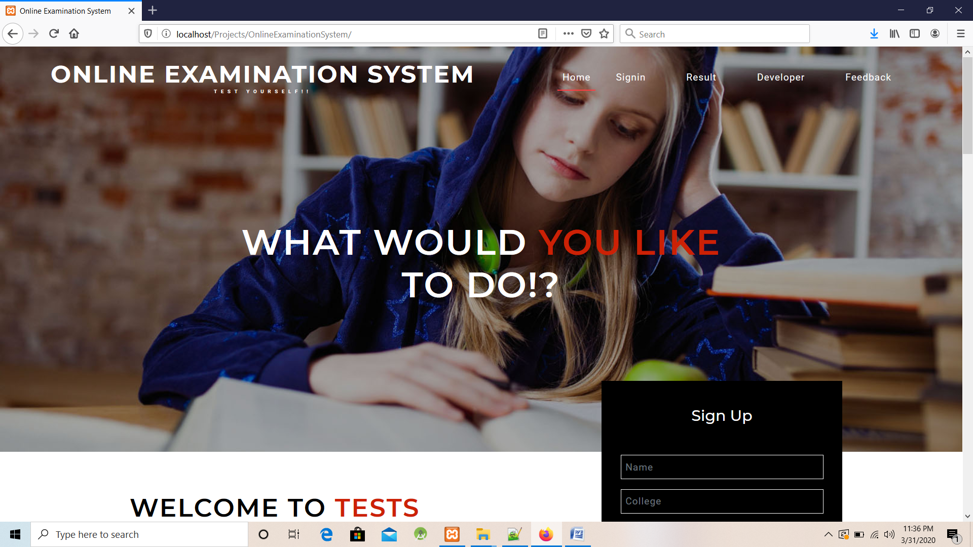

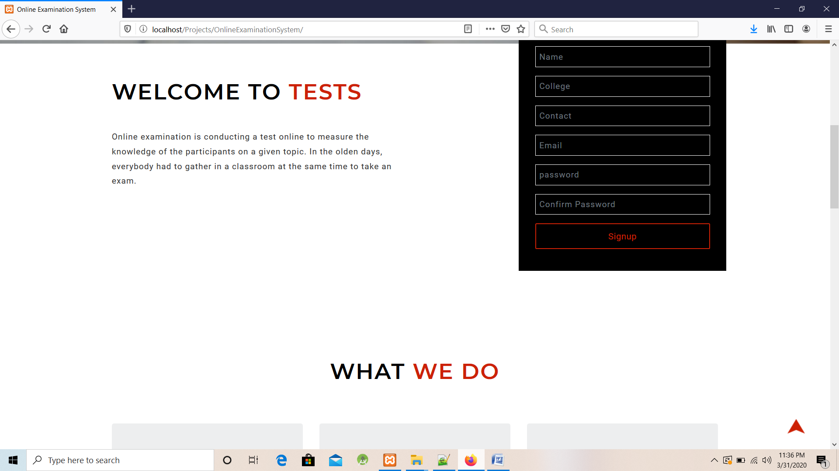



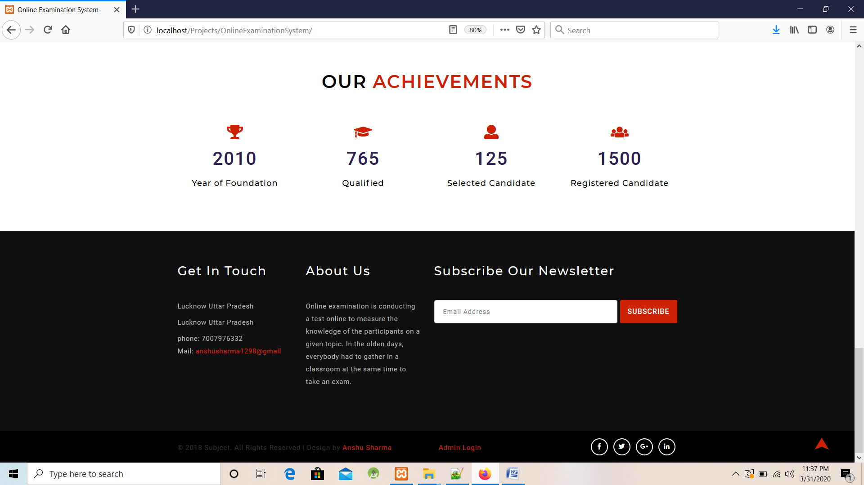

Login Model

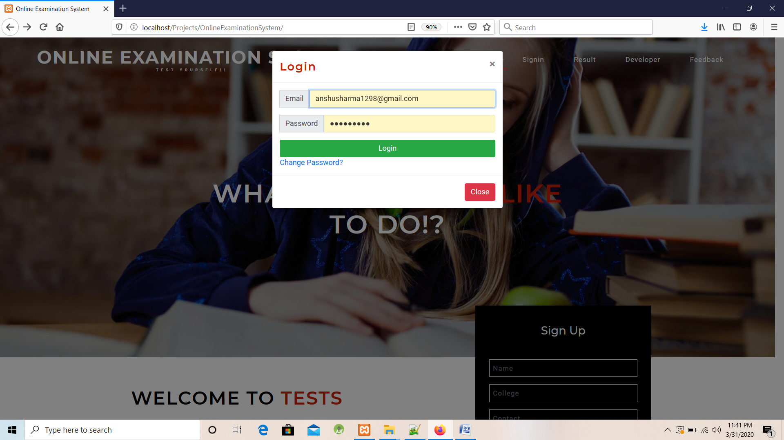

Result Model

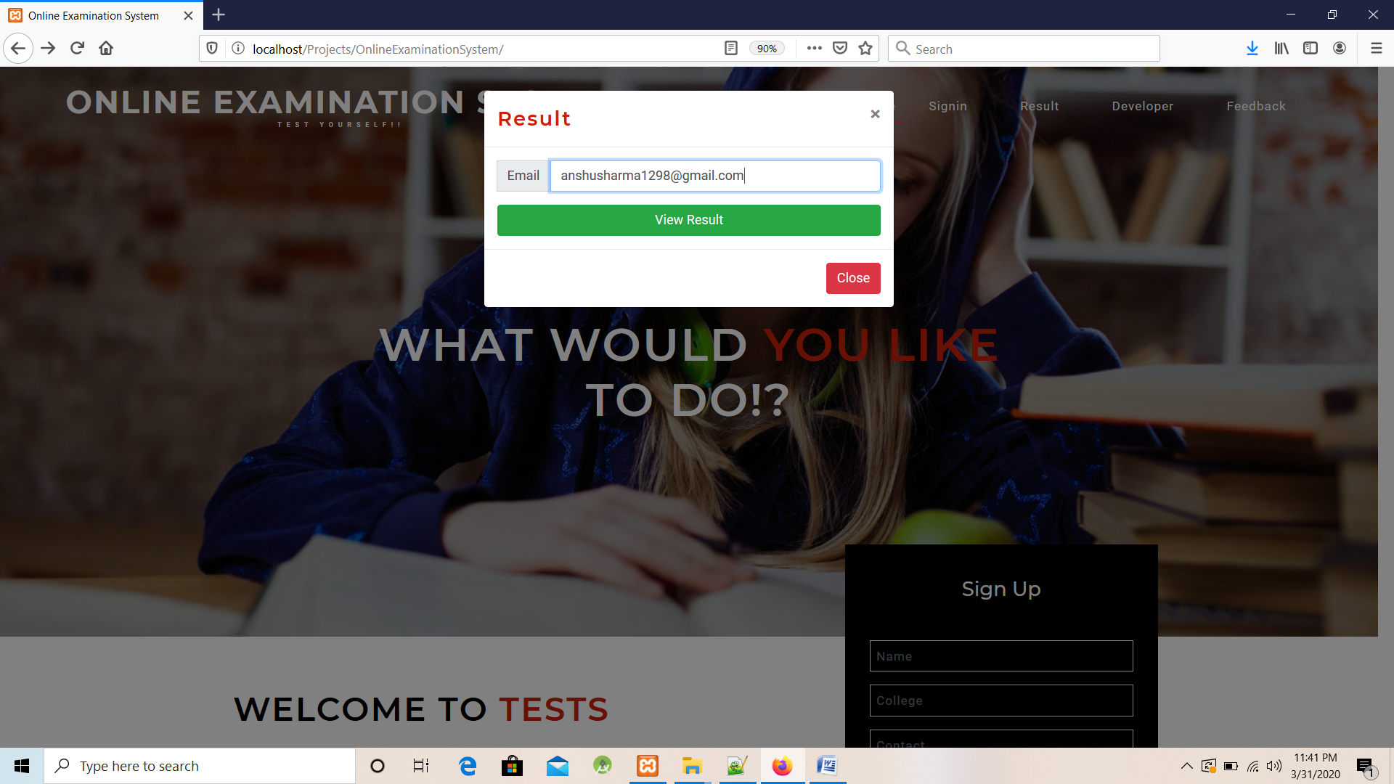

Developer Model

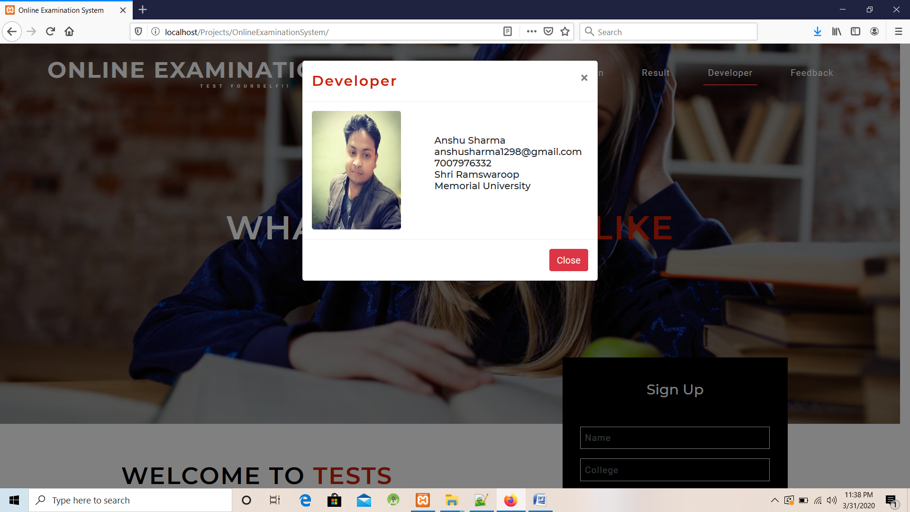

Feedback.php

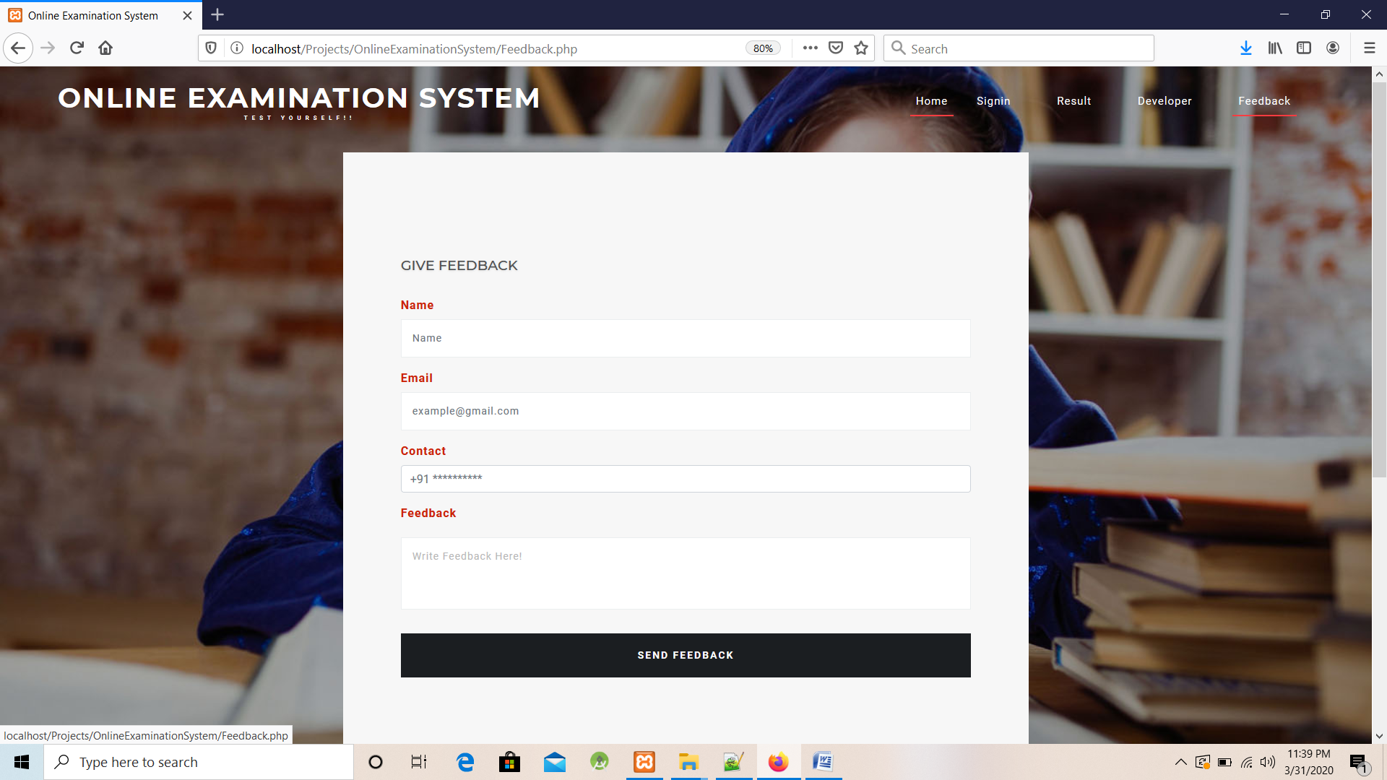

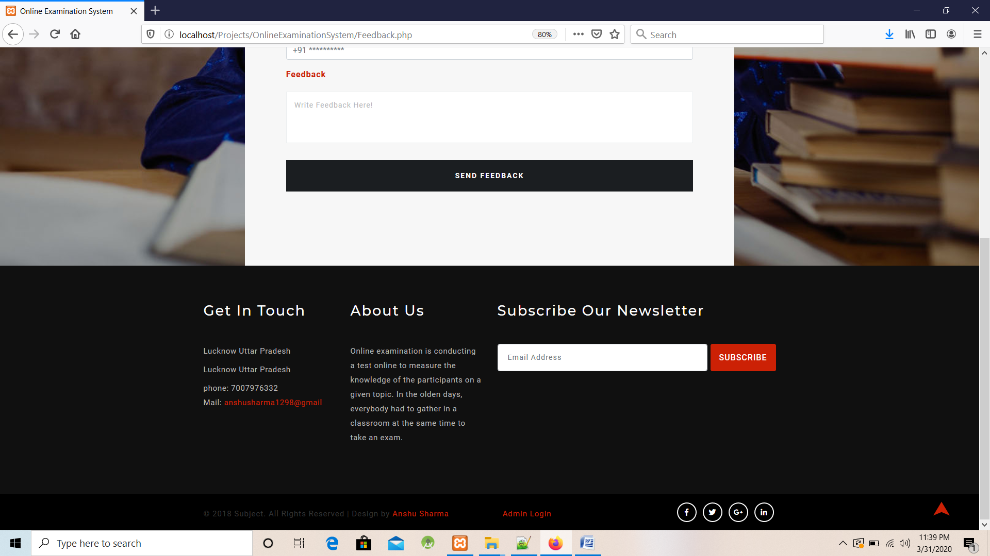

TestCategory.php

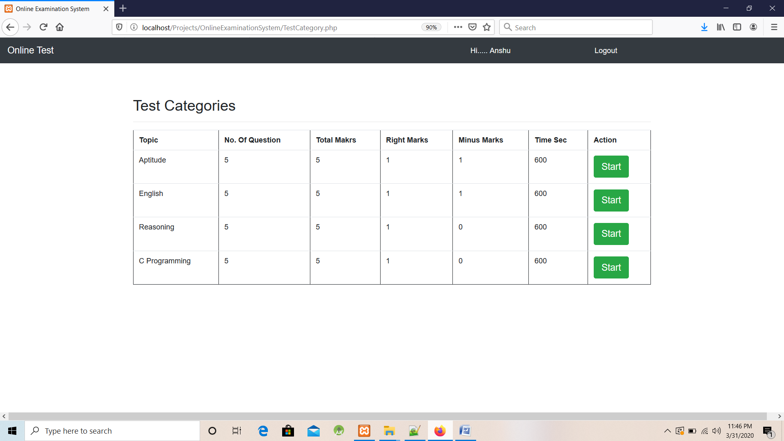

Quiz.php

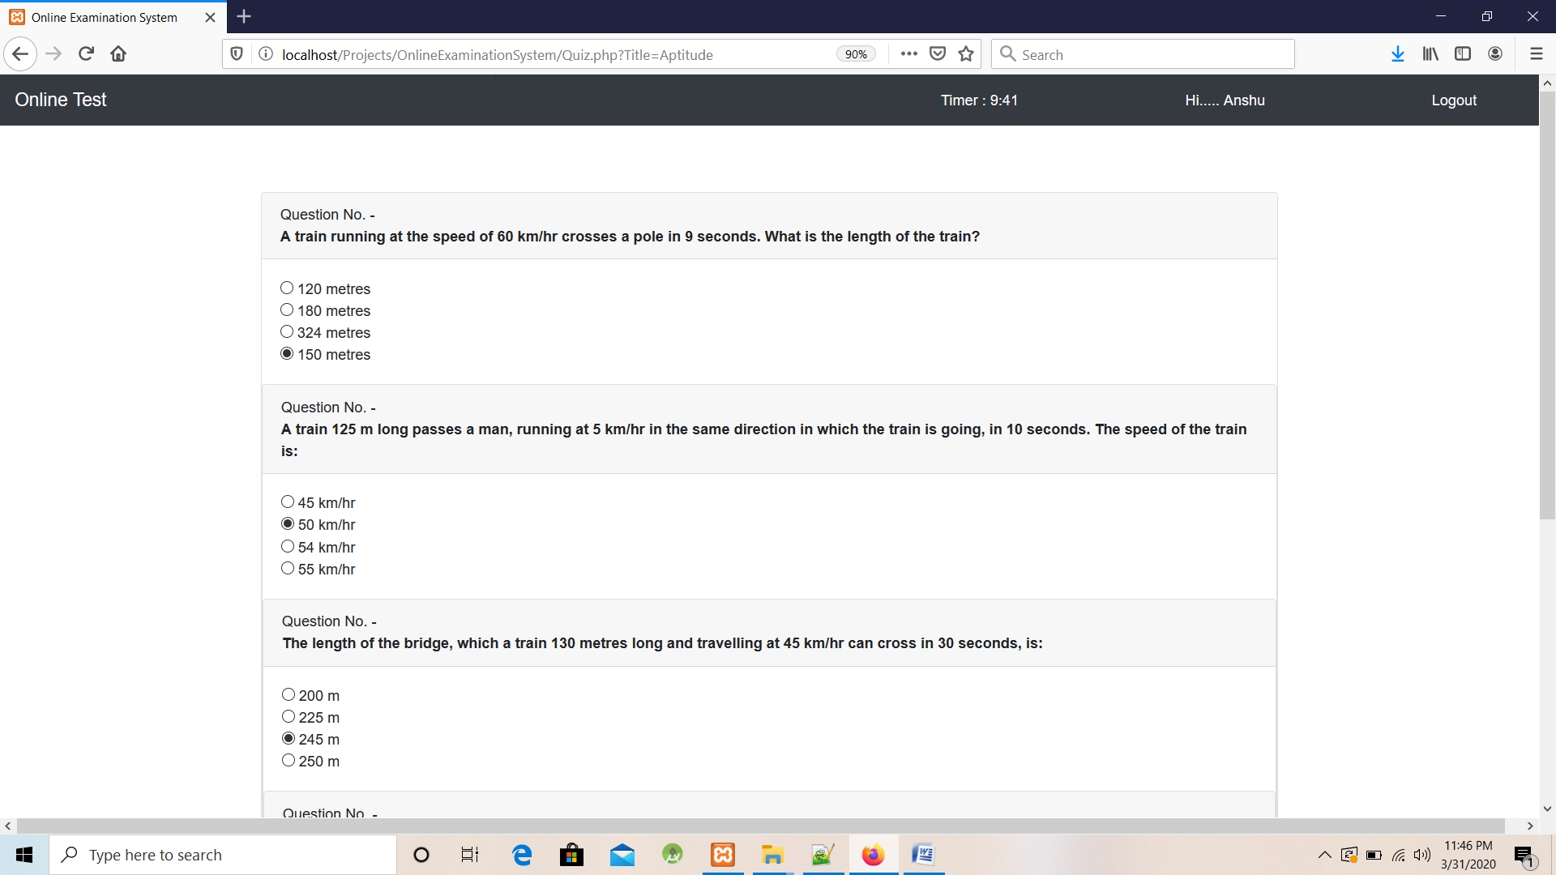

Check.php

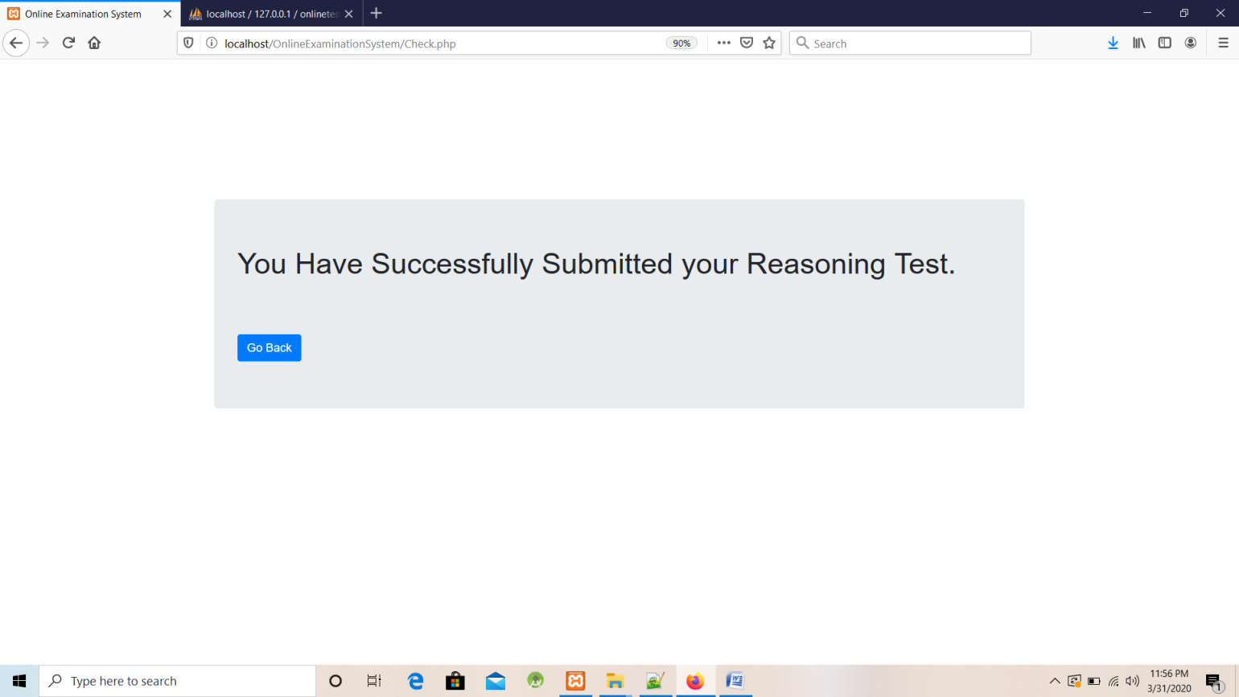

Result.php

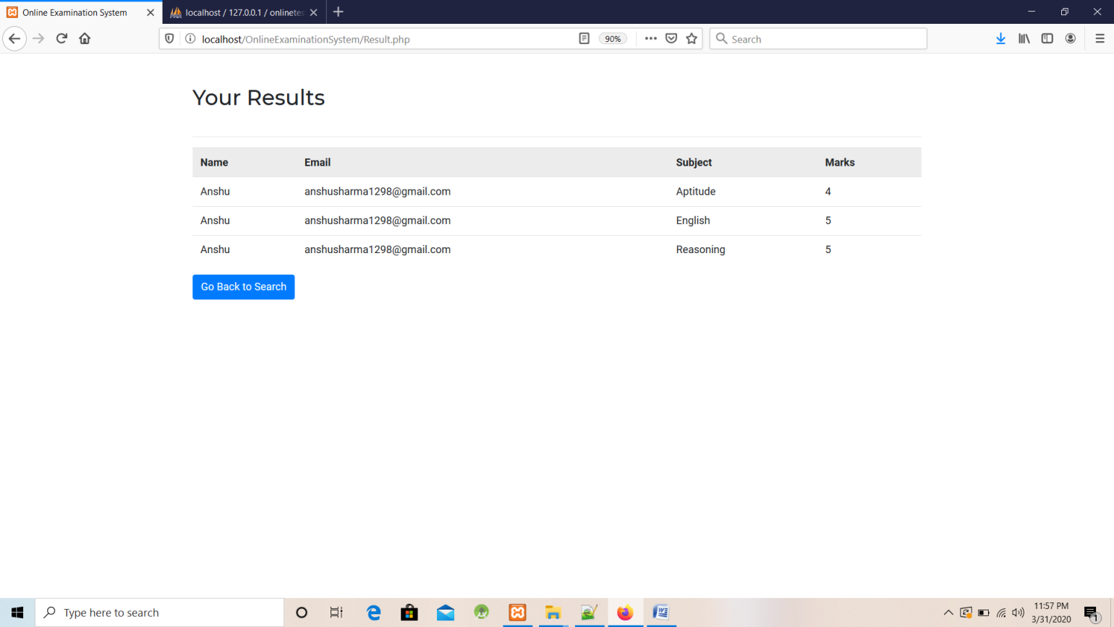

Changepwd.php (User Change his/her Password)

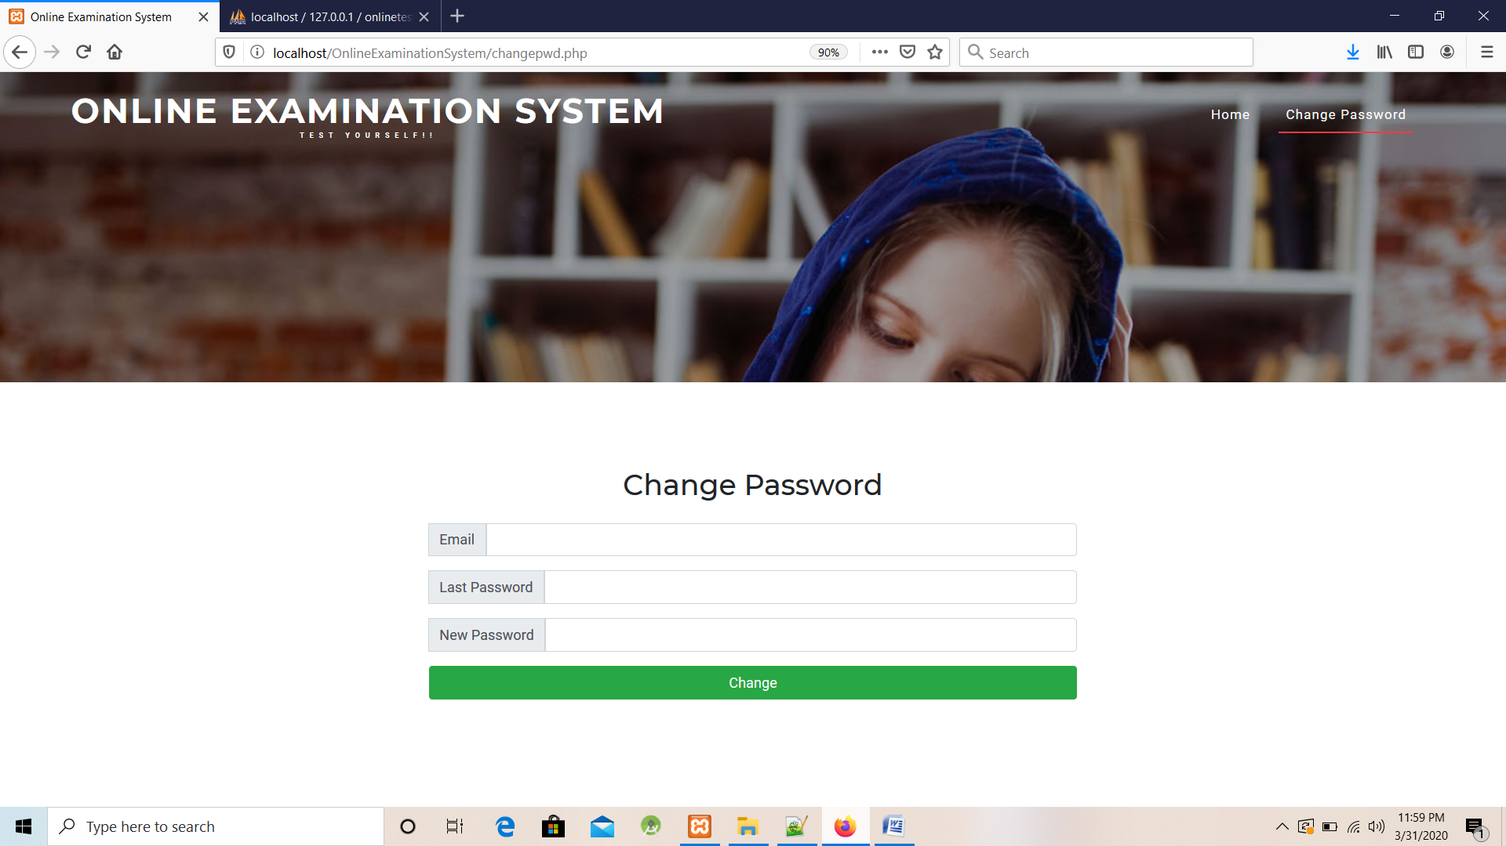

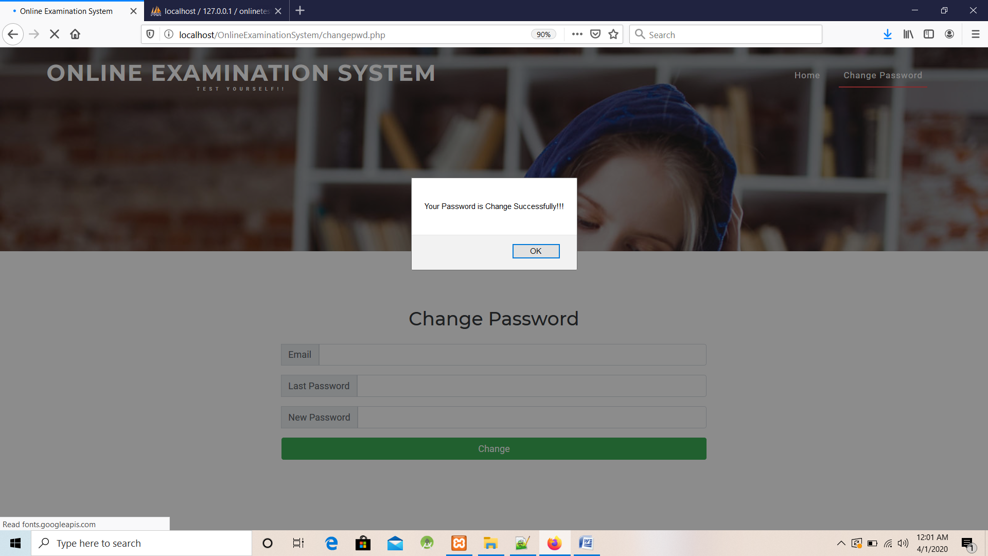

Login.php(Admin Login)

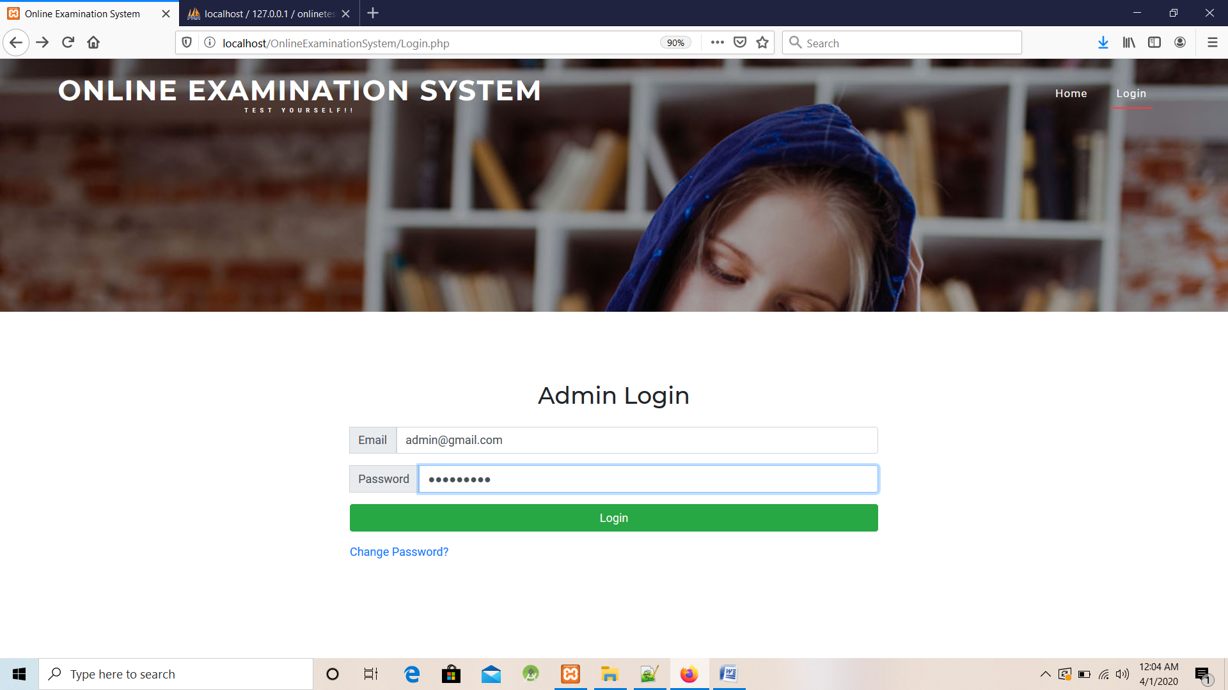

Admin Home Page (index.php)

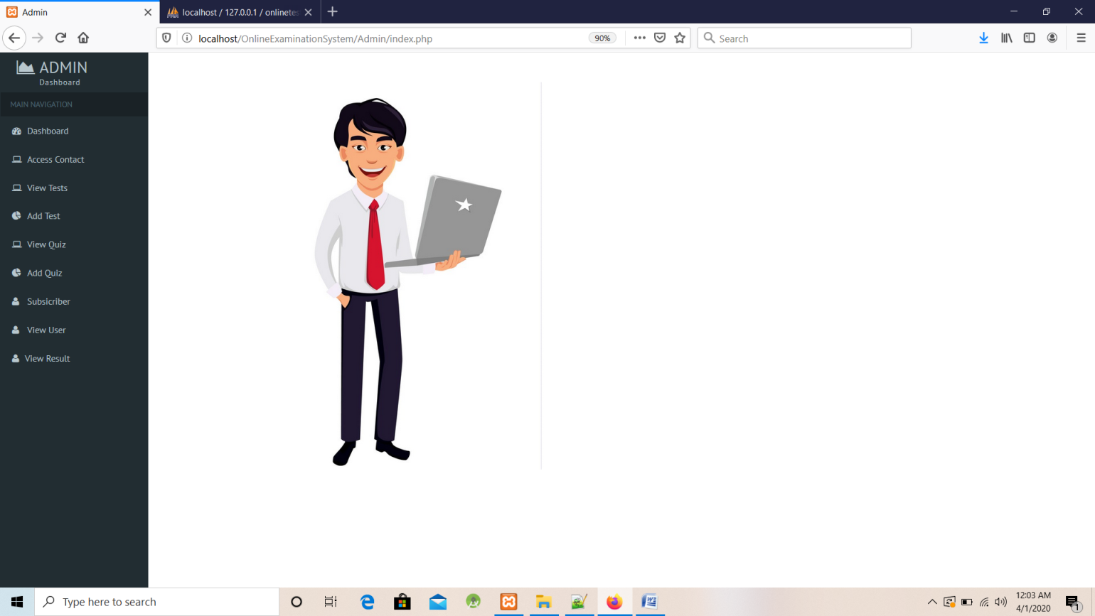

AccessContact.php

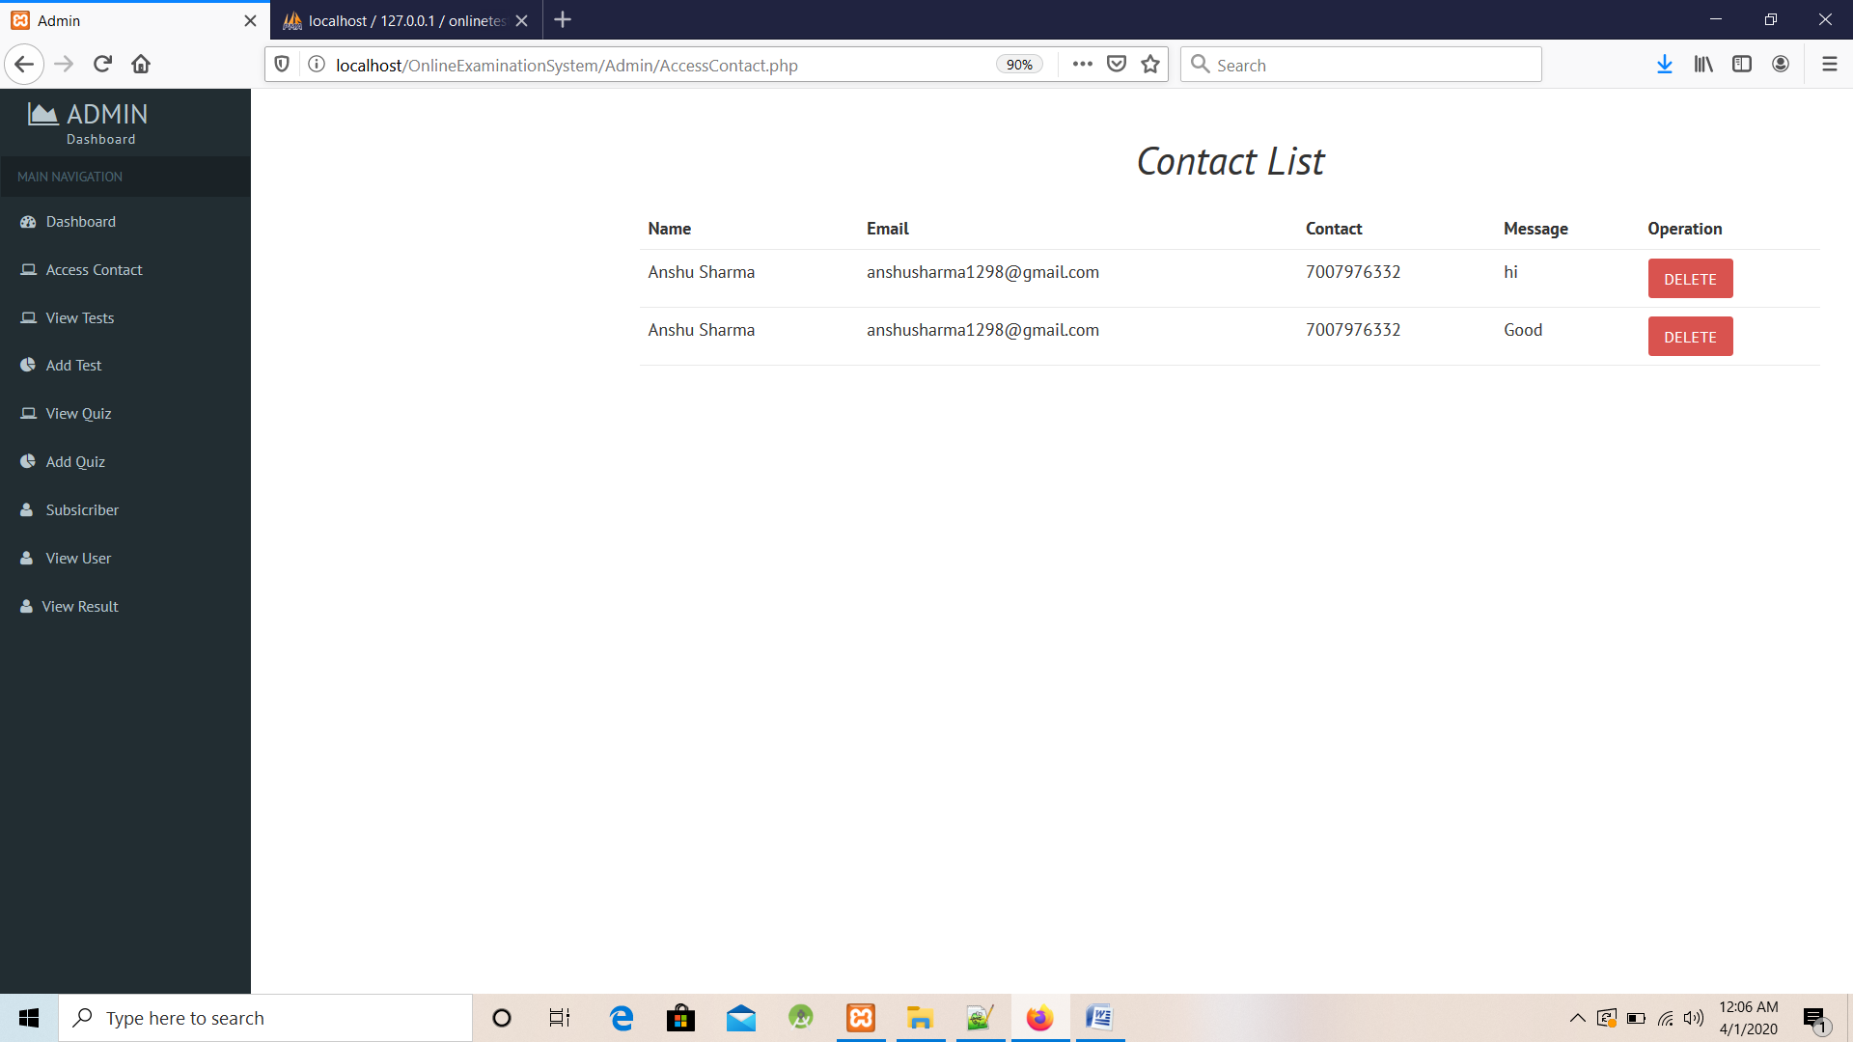

ViewTest.php

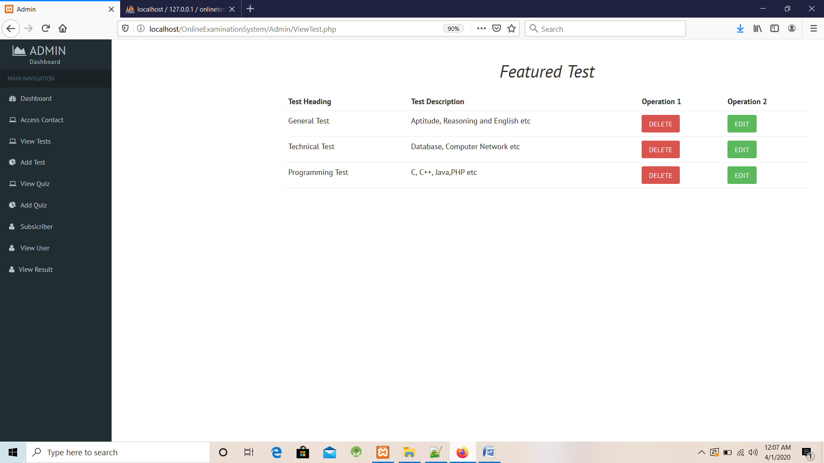

AddTest.php

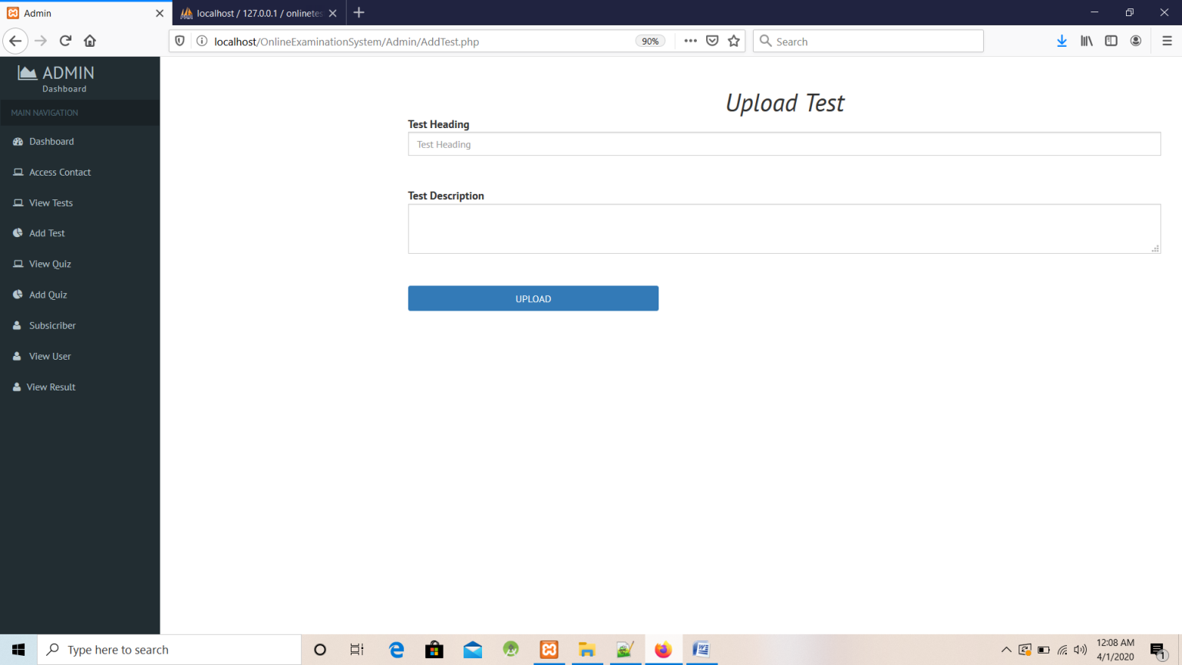

ViewQuiz.php

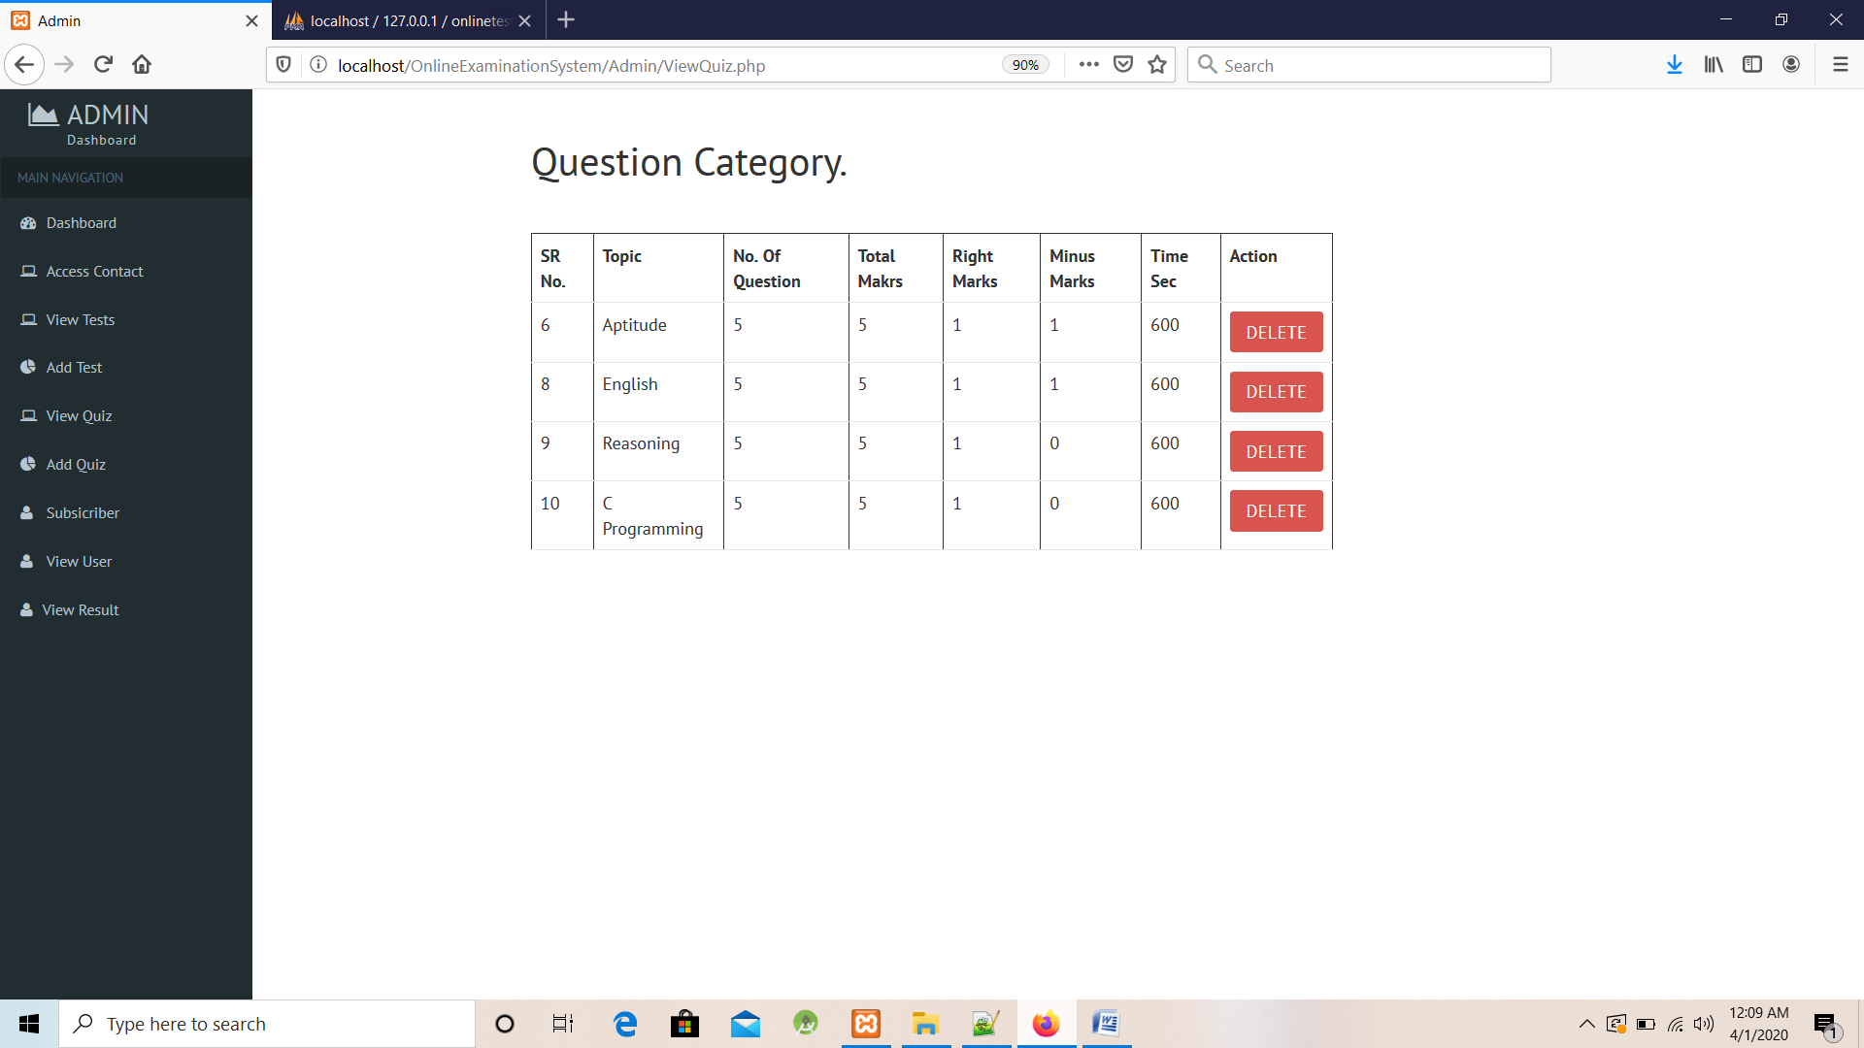

AddQuiz.php

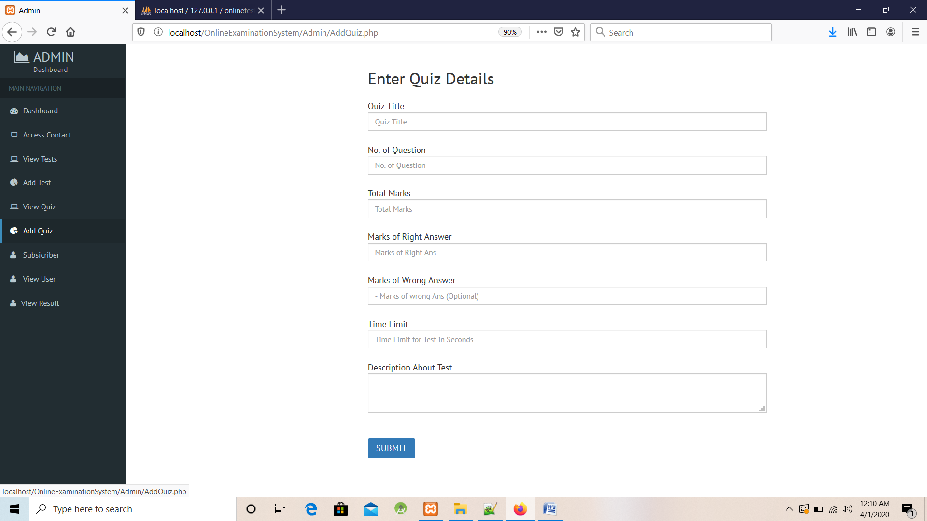

AddQuestion.php

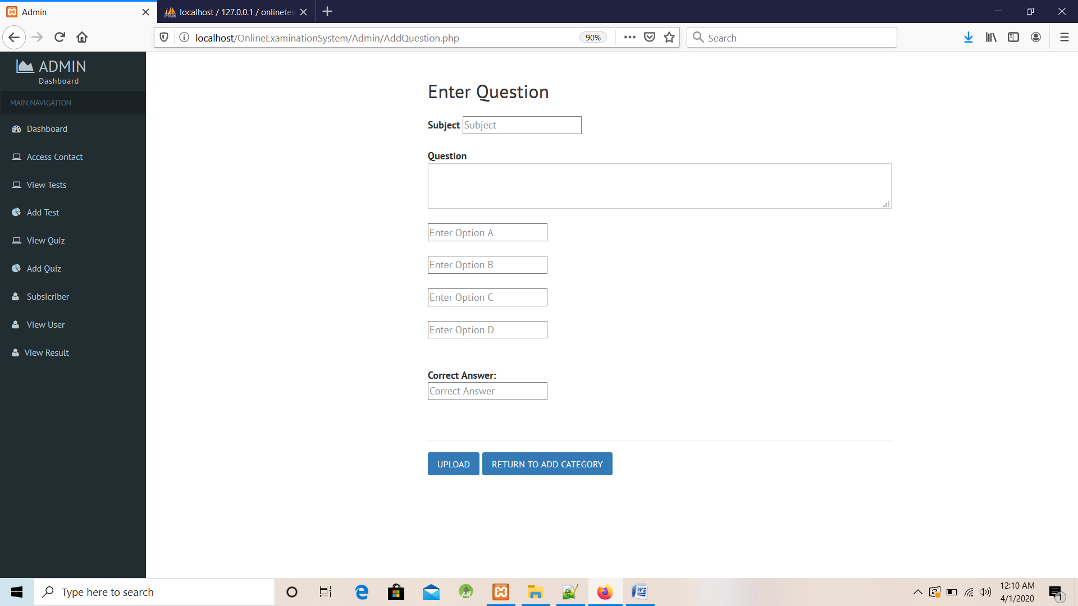

Subscriber.php

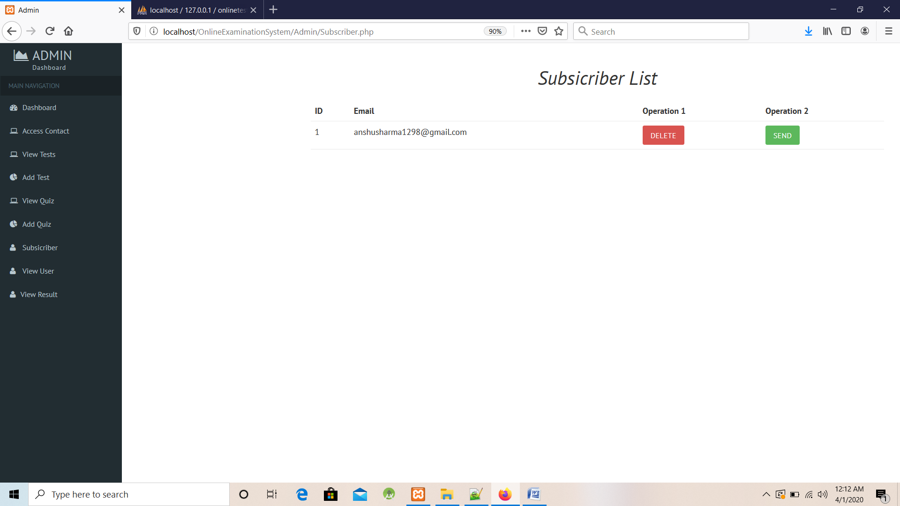

ViewRegister.php (View Register User)

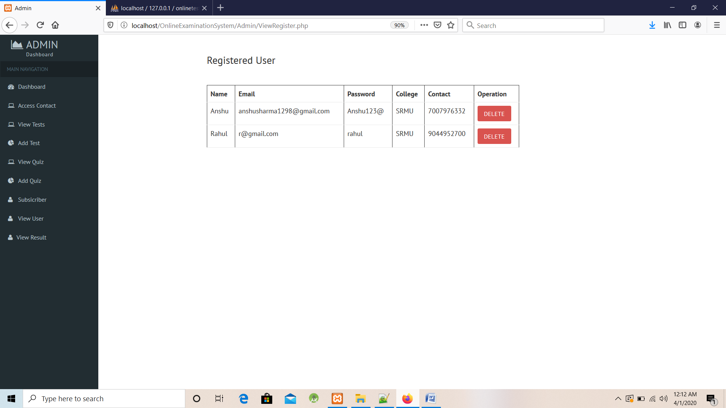

Result.php

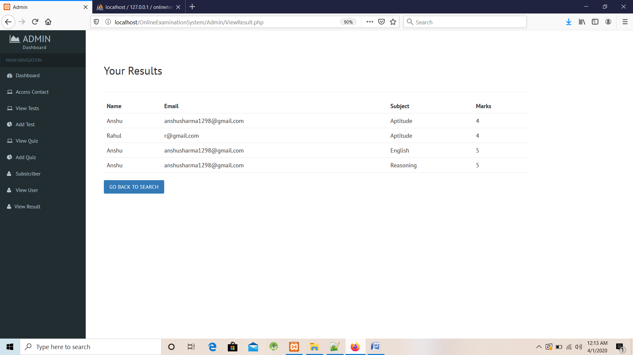

**CONCLUSION:**

The package was designed in such a way that future modifications can be done easily. The following conclusions can be deduced from the development of the project.

* + Automation of the entire system improves the efficiency
  + It provides a friendly graphical user interface which proves to be better when compared to the existing system.
  + It gives appropriate access to the authorized users depending on their permissions.
  + It effectively overcomes the delay in communications.
  + Updating of information becomes so easier.
  + System security, data security and reliability are the striking features.
  + The System has adequate scope for modification in future if it is necessary.

**FUTURE ENHANCEMENTS:**

This application avoids the manual work and the problems concern with it. It is an easy way to obtain the information regarding the different scheduled examinations information that are

Currently issued.

Well I and my team members have worked hard in order to present an improved website better than the existing one’s regarding the information about the various activities. Still ,we found out that the project can be done in a better way. Primarily, when we request information about a particular schedules it just shows the exam date and platform. So, after getting the information we can get access to the online exam.

The enhancement that we can add the searching option. We can directly search to the particular student details from this site.

**BIBLIOGRAPHY**

The following books were referred during the analysis and execution phase of the project

* **Books Referred:**
* BEGINNING PHP 5 ---DAVE MERCER
* BLACK BOOK HTML ---WILEY DREAMTECH
* PHP AND MYSQL WEB DEVELOPMENT --- LUKEWELLING,LAURA
* MICROSOFT SQL SERVER-2000 ---RANKIN, PAUL & JENSEN
* SQL SERVER-2000 ---DUSAN PETKOVIC
* PHP IN A NUTSHELL --- PAUL HUDSON
* **Websites Referred:**

http://www.projectworlds.in